XLurn - User Manual
Enterprise Video Streaming & Course Learning Management System (LMS)
Document Version: | 2.4.0 (Production Enterprise Release)
Target Roles: | Super Admin | Client Admin | Author Admin | Learner (User)
Scope: | Admin Web Portal, Learner Web App, Video Transcoding & Upload Service
Date & Status: | September 2026 | Approved Official Release

Document Control
Document Title: Enterprise Video Streaming & LMS Standard Operating Procedure (SOP)
Version: 2.4.0
Applicable Platforms: Admin Web Portal (admin-web-app), Learner Portal (user-web-app), Transcoding & Upload Service
Target Audience: Super Administrators, Client Administrators (Admins), Author Administrators (Instructors/Creators), and End Learners (Users)
Table of Contents
1. Platform Architecture & Role-Based Access Matrix
2. Section A: Super Admin SOP Manual
2.1 Super Admin Authentication & Global Dashboard
2.2 Client Management
2.3 Admin & Author Governance
2.4 Global User Management & Security Audits
2.5 Global Content Catalog (Courses, Categories, Subcategories)
2.6 Platform Analytics, AI Insights & Support Center
3. Section B: Client Admin (Organization Admin) SOP Manual
3.1 Admin Authentication & Dashboard Overview
3.2 Author (Instructor) Management
3.3 Student / Learner Management & Activity Logs
3.4 Content & Video Catalog Management
3.5 Course Upload & Curriculum Builder (Chapters & Lessons)
3.6 Quiz & Assessment Engine Management
3.7 Sub-Admins, Roles, Permissions & Audit Trail
4. Section C: Author Admin (Instructor / Content Creator) SOP Manual
4.1 Author Dashboard & Studio Workspace
4.2 Video Upload & Transcoding Pipeline
4.3 Course Curriculum Authoring & Draft Workflow
4.4 Interactive Quiz Question Creation
5. Section D: End Learner (User) Portal SOP Manual
5.1 Account Registration, Login, OTP & Password Recovery
5.2 Home Feed, Category Browsing & Search
5.3 Course Enrollment & Video Watch Room
5.4 Video Player Controls, Anti-Piracy Watermarks & Fullscreen
5.5 Chapter Quizzes & Assessment Submissions
5.6 Watch Later & Favorites Workflow
5.7 Profile Settings, Security & Subscription Plans Upgrade
5.8 Virtual Classroom & Live Interactive Lectures
5.9 Collaborative Study Rooms & Watch Parties
5.10 Community & Discussion Boards
5.11 Earned Certificates & Verified Credentials
5.12 Help Center & Self-Service FAQ
6. Section E: System Error Codes & Troubleshooting Reference

1. Platform Architecture & Role-Based Access Matrix
Feature / Module | Super Admin | Client Admin | Author Admin | Learner (User)
Multi-Client Client Management | Full Access | No Access | No Access | No Access
Admin Account Provisioning | Full Access | Read / Edit Self | No Access | No Access
Author / Instructor Creation | Full Access | Full Access | Self Profile Only | No Access
User / Learner Account Governance | Global Control | Organization Control | View Enrolled | Self Profile
Global Categories & Subcategories | Full Access | Full Access | Read-Only | Read-Only
Video Upload & Transcoding Service | Full Access | Full Access | Full Access | No Access
Course Curriculum & Chapter Builder | Full Access | Full Access | Full Access | Enrolled View
Quiz Assessment Engine | Full Access | Full Access | Full Access | Take & Submit
Roles, Permissions & Audit Logs | Full Access | Organization Control | No Access | No Access
Subscription & Plan Management | Global Control | Organization Control | Read-Only | Purchase / Upgrade
Video Player & Anti-Piracy Watermark | Preview Mode | Preview Mode | Preview Mode | Full Dynamic Streaming

2. Section A: Super Admin

2.1 Super Admin Authentication & Global Dashboard
Objective: To monitor macro platform vitals, user growth, aggregate storage utilization, total active clients, and system-wide video engagement.
Step-by-Step Navigation:
1. Open the Admin Web App URL (http://localhost:3000 or production domain).
2. Enter Super Admin credentials (username/email and password).
3. Click Login.
4. You are redirected to the Super Admin Global Dashboard (/superadmin).
5. Review the primary KPI summary metrics:
• Total Clients
• Total System Users & Growth Trends
• Total Published Courses & Transcoded Videos.
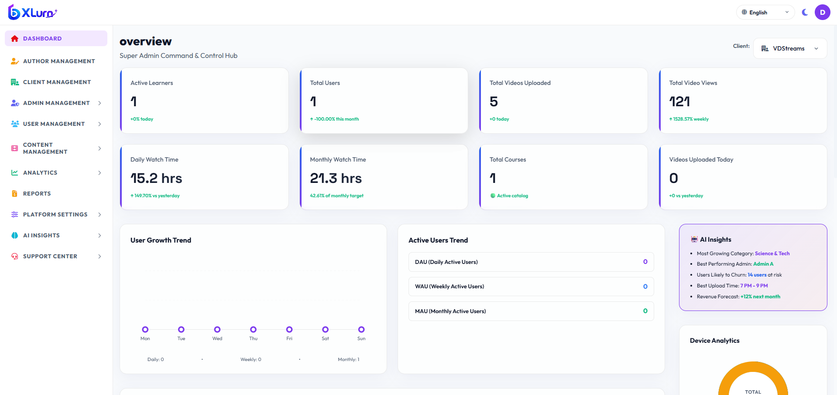

2.2 Client Management
Objective: Provisioning, onboarding, and configuring enterprise client clients.
Step-by-Step Navigation & Actions:
1. On the left sidebar menu, click Client Management.
2. View Clients: The table lists Organization Name, Client Admin Email, Subscribed Tier, Status (Active/Suspended), and Creation Date.
3. Onboard New Client:
• Click the `+ Add Client` button.
• Fill in the required modal fields:
• Organization Name: Legal client name.
• Domain / Slug: Unique client identifier.
• Primary Admin Email: Contact for primary organization owner.
• Click Submit / Create Client.
4. Manage Client Status:
• In the action column, click Edit to modify quotas or Deactivate/Activate to suspend access.
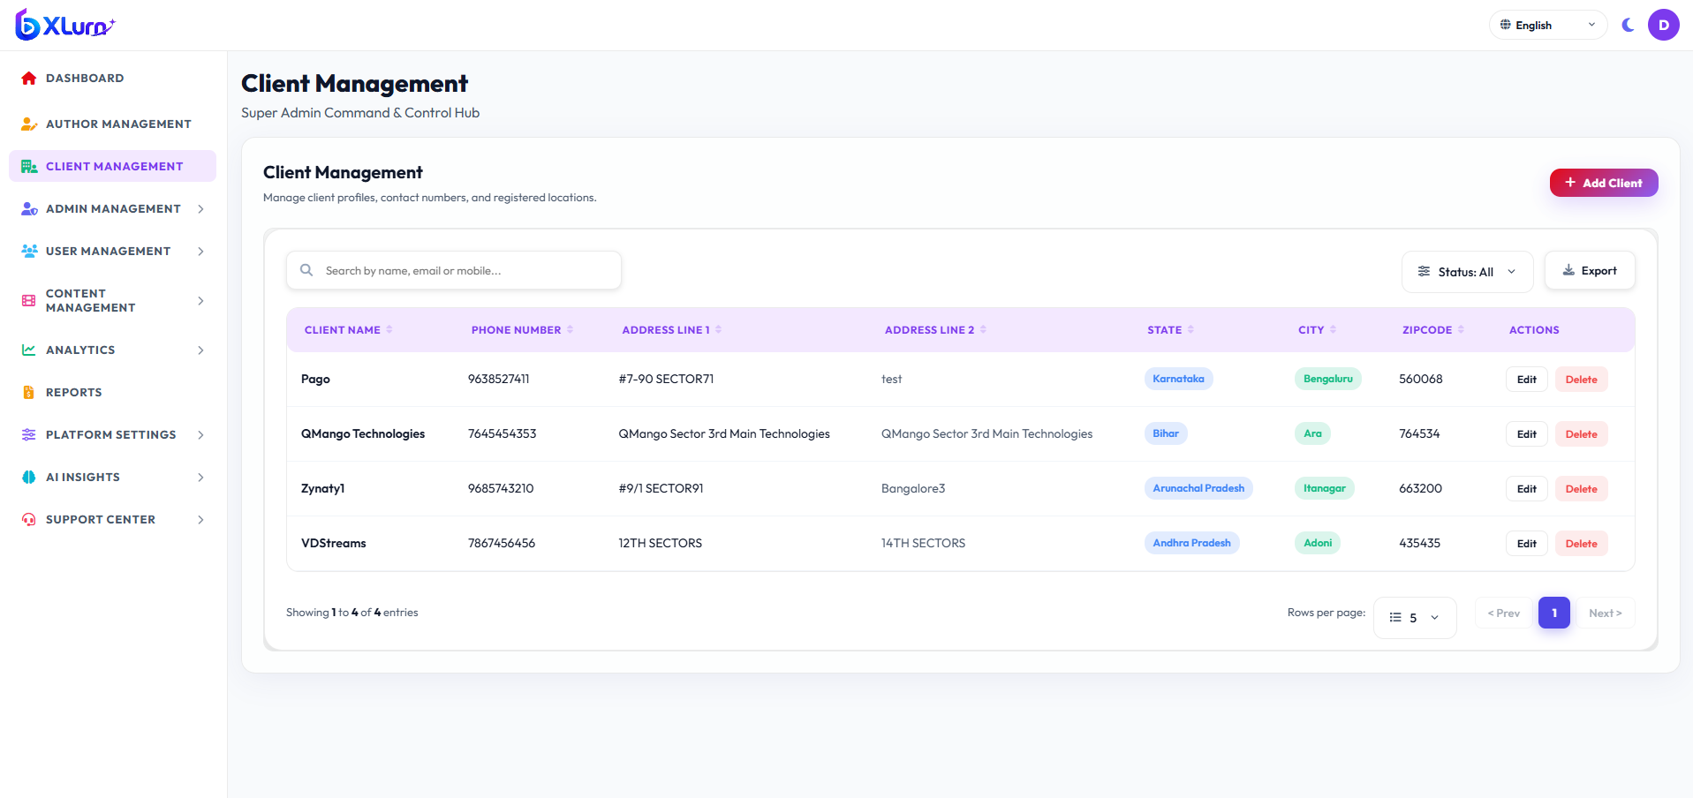

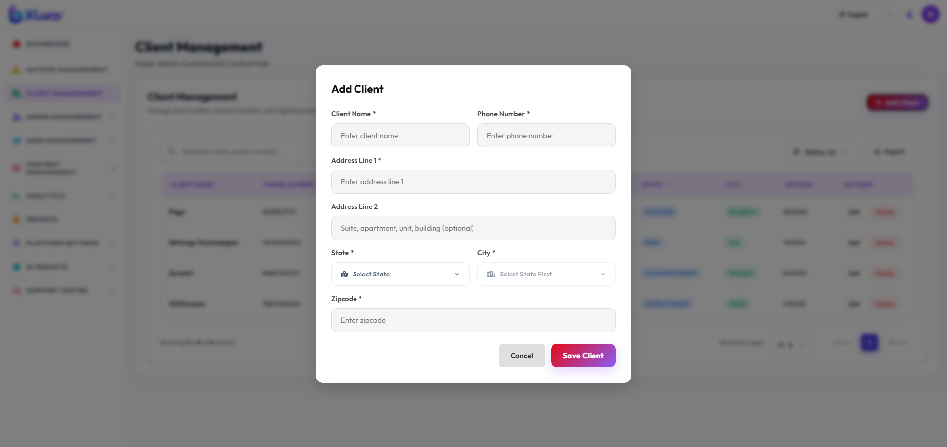

2.3 Admin & Author
Objective: Governing Organization Administrators and Content Authors across the entire platform.
Step-by-Step Navigation:
1. Navigate to Admin Management -> All Admins.
2. Filter: Filter by Client ID, Status, or Search by Name/Email.
3. Provision Client Admin:
• Click `+ Add Admin`.
• Select the target Client.
• Input Admin Full Name, Email, Password, and Role assignment.
• Click Save.
4. Navigate to Author Management:
• Inspect cross-client authors, bio profiles, approval states, and assigned courses.
• Click `+ Add Author Admin`.
• Input Admin Full Name, Email, Password, and Role assignment and based on client.
• Click Save.
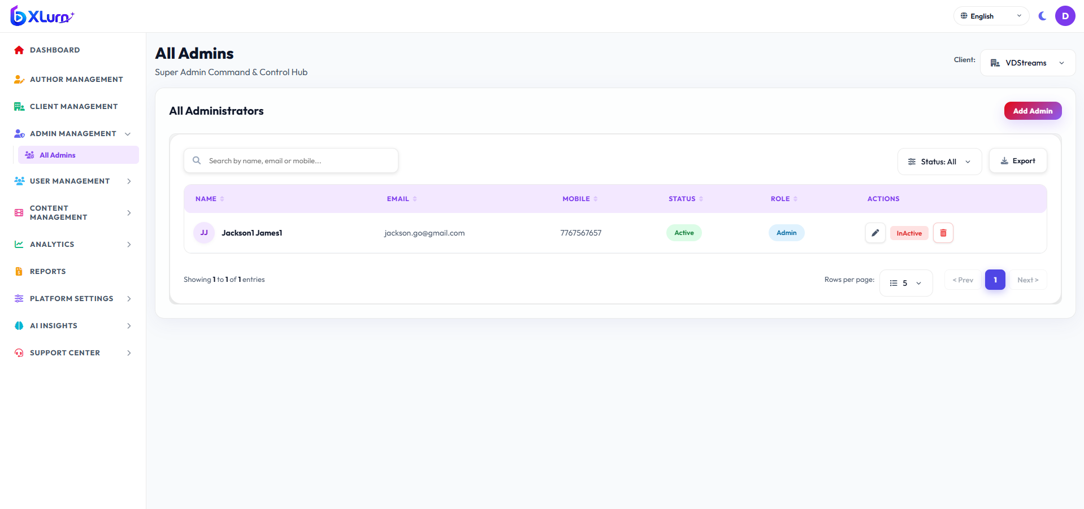

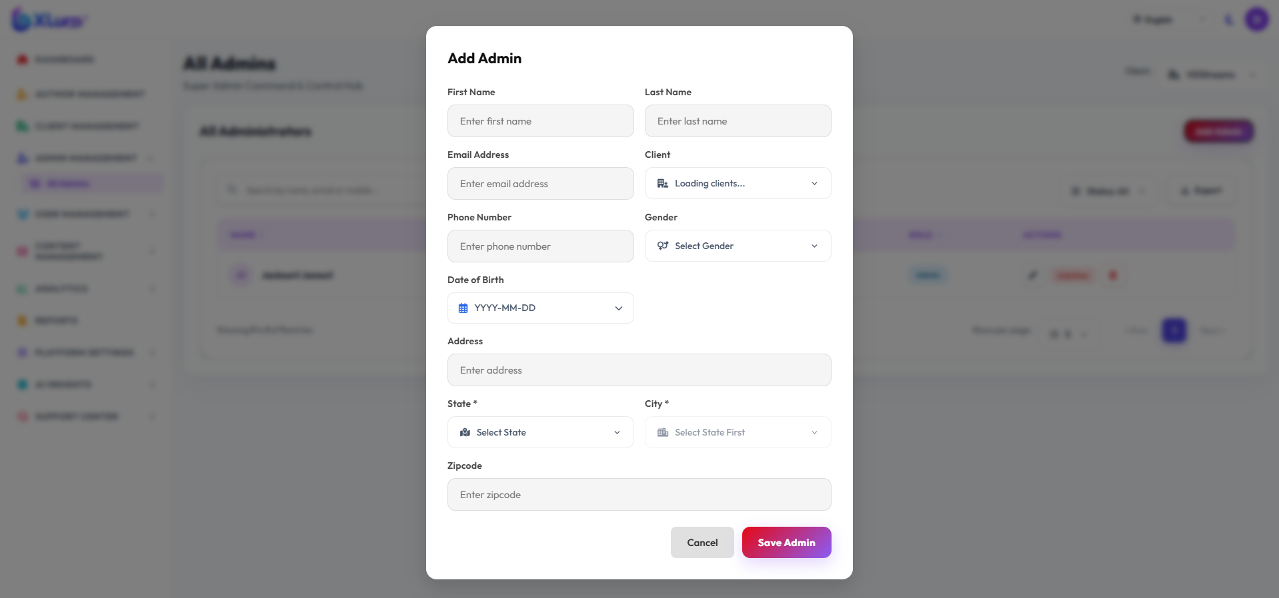

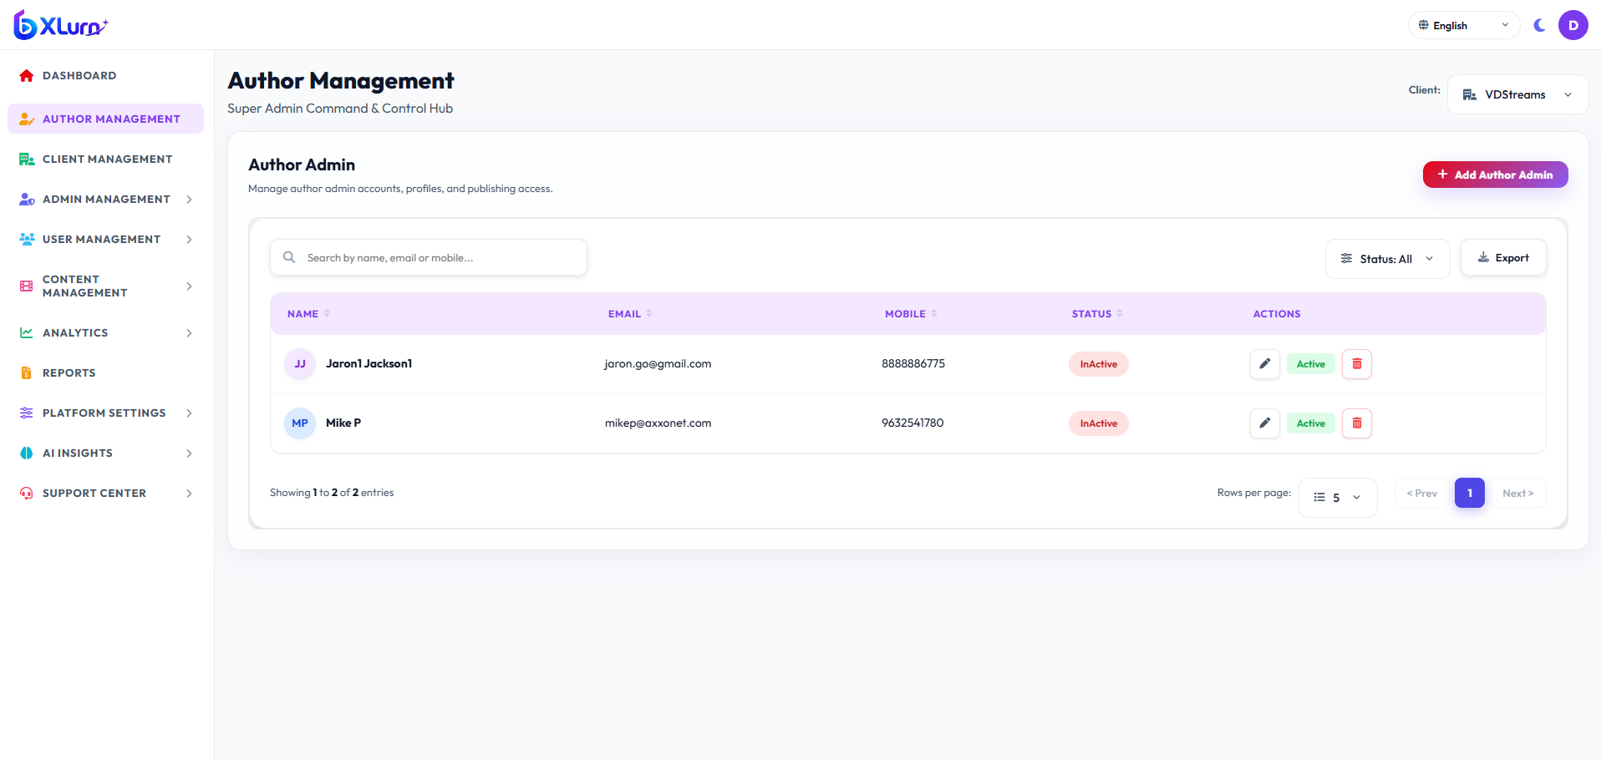

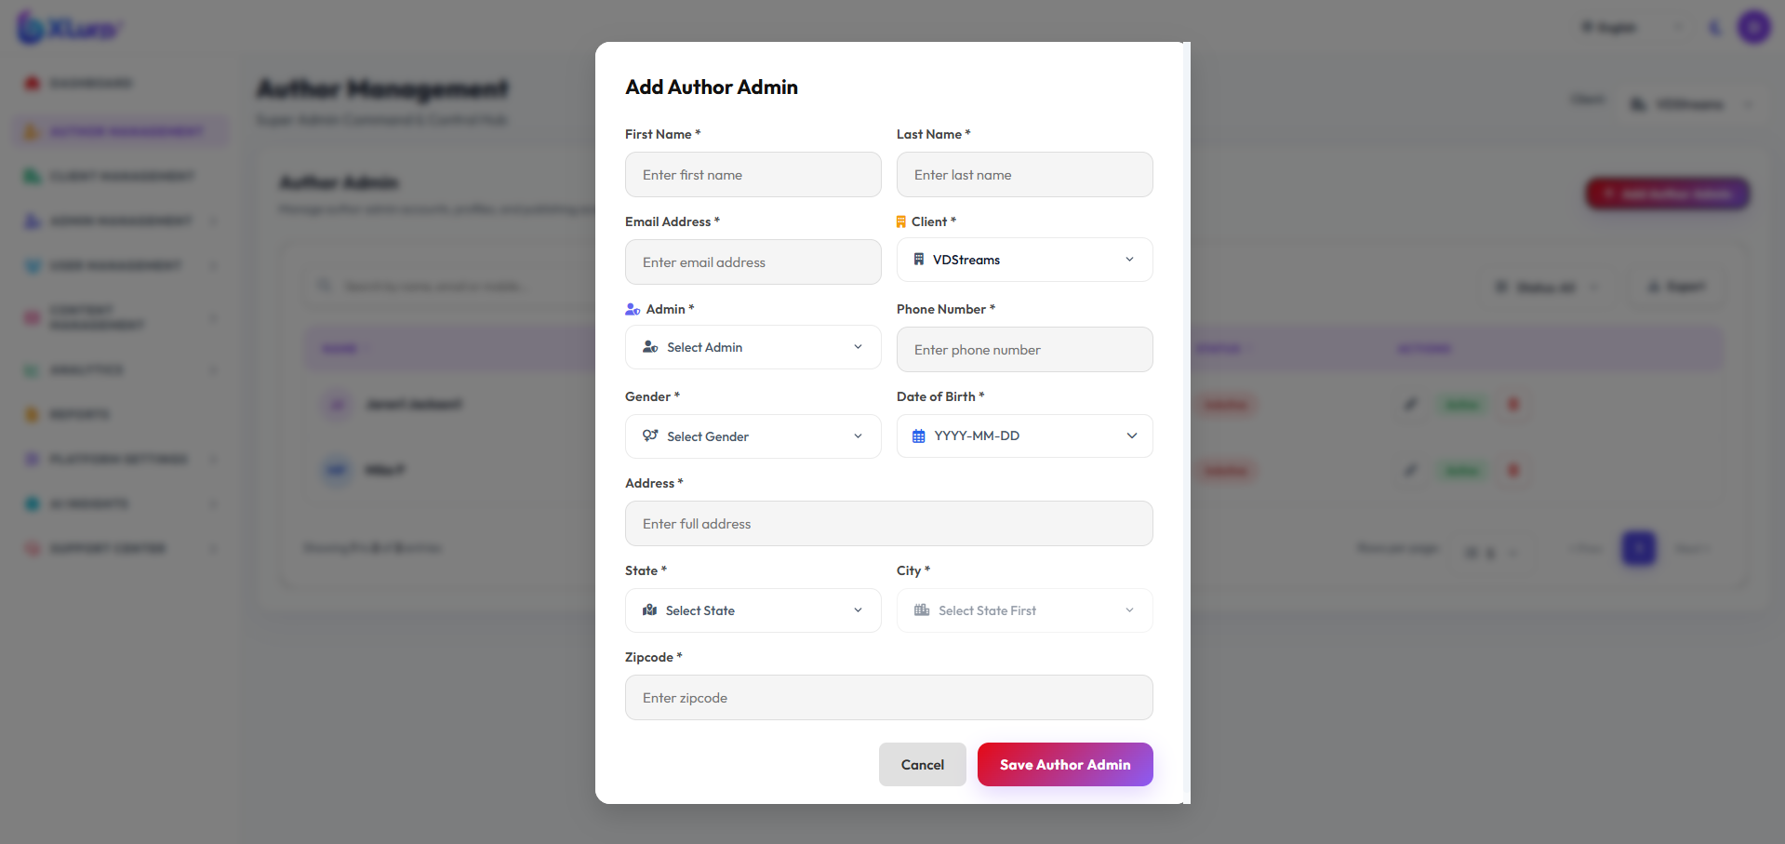

2.4 Global User Management & Security Audits
Objective: Monitor all registered learners, manage deactivation/blocking, and inspect security audit logs.
Step-by-Step Navigation:
1. Navigate to User Management:
• All Users: Comprehensive listing of every learner across all organizations.
• User Activity Logs: Real-time trail showing login timestamps, IP addresses, watch events, and device user-agents.
• Blocked Users: Interface to review flagged/blocked accounts and restore or permanently delete them.
2. Account Deactivation Handling:
• Clicking Block/Deactivate sets user status code to inactive. Any subsequent request by that user triggers HTTP 430: "Your account has been deactivated. Please contact your administrator."
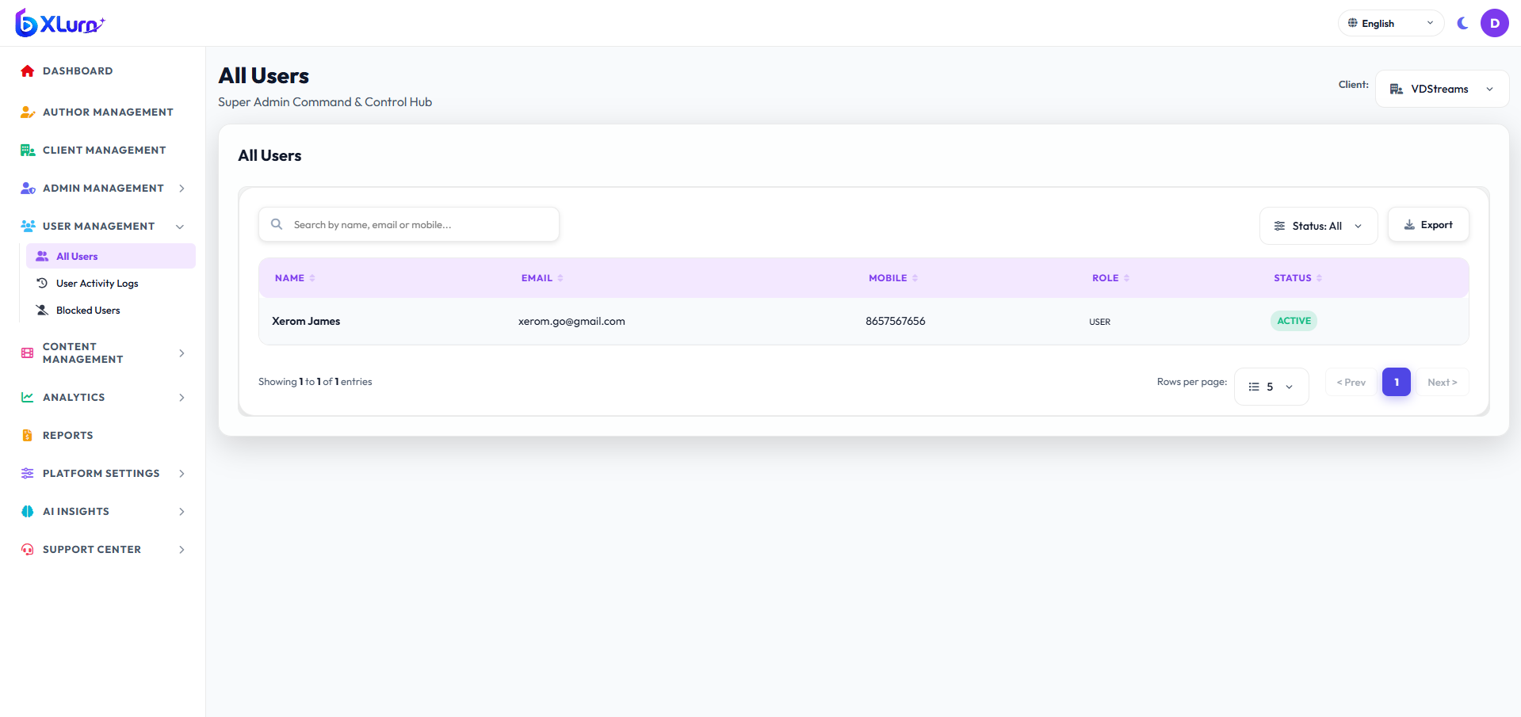

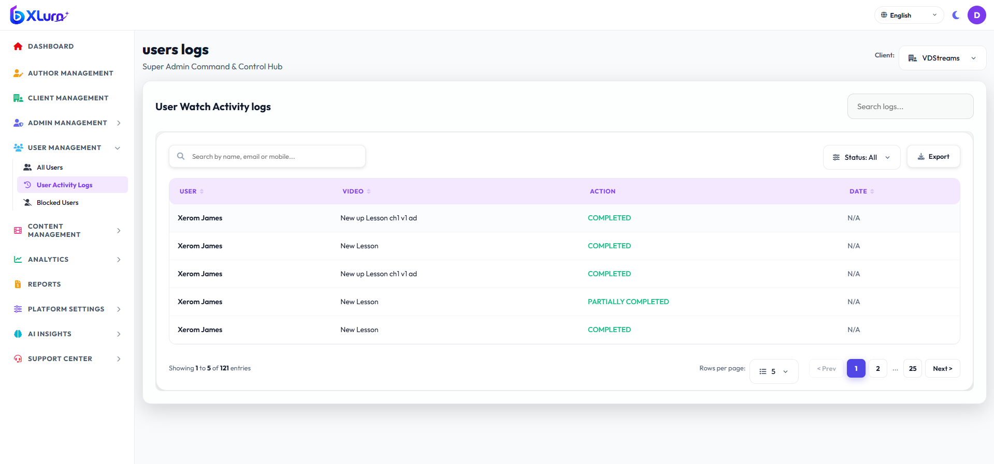

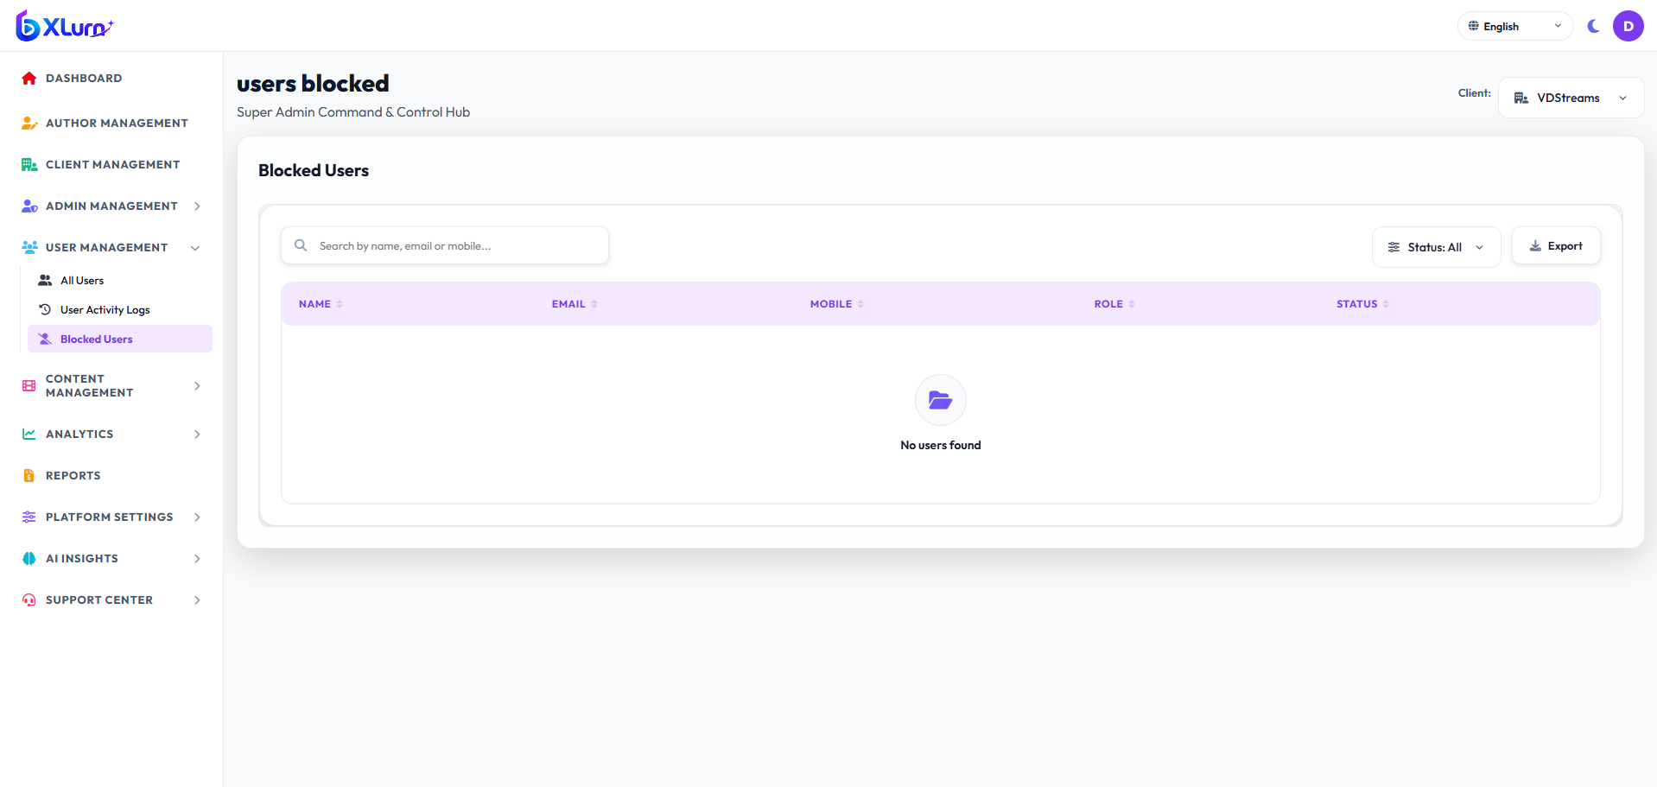

2.5 Global Content Catalog
Objective: Manage global taxonomy (Categories and Subcategories) and perform global course publishing audits.
Step-by-Step Navigation:
1. Click Content Management on the sidebar.
2. Categories:
• Click Categories -> click `+ Add Category`.
• Enter Category Title, Slug, Display Order, and Icon class.
• Click Save.
3. Subcategories:
• Click Sub Category -> click `+ Add Subcategory`.
• Select Parent Category from dropdown.
• Enter Subcategory Title and Description.
4. Course And Videos:
• Click All Courses to inspect any course across clients. View status, visibility (Free/Paid), chapters, and review author submissions.
• Click All Videos to inspect any videos across clients. View status, visibility (Free/Paid), chapters, and review author submissions.
• Upload courses and upload video.
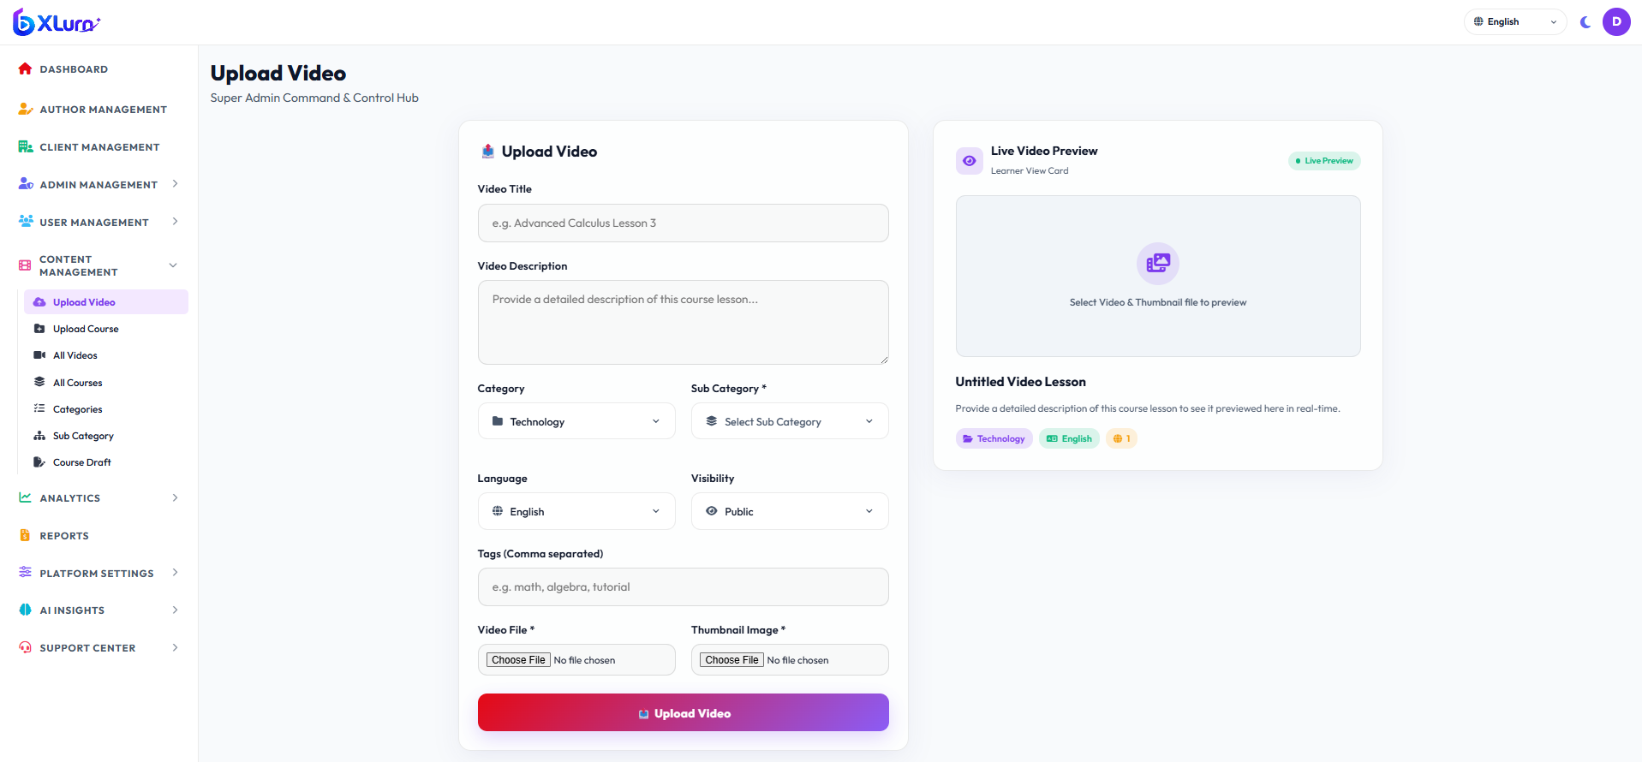

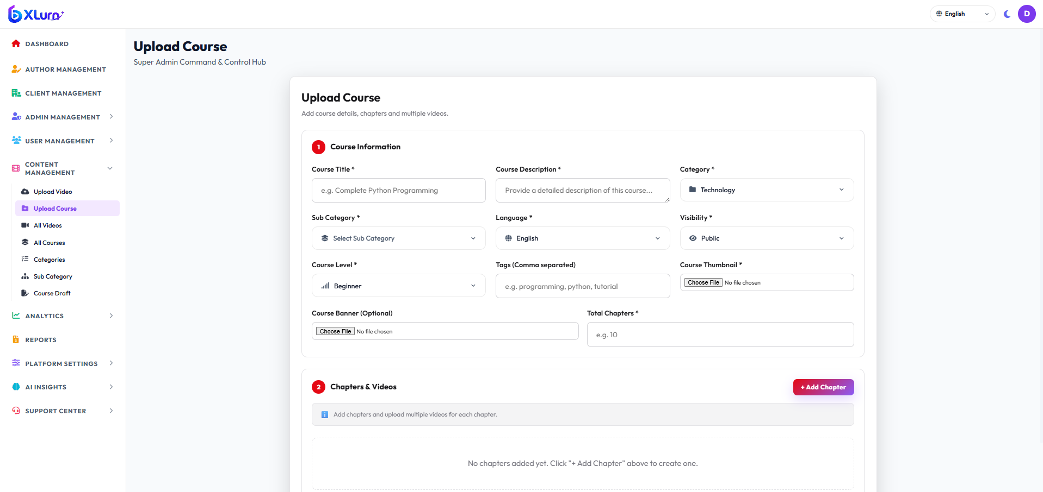

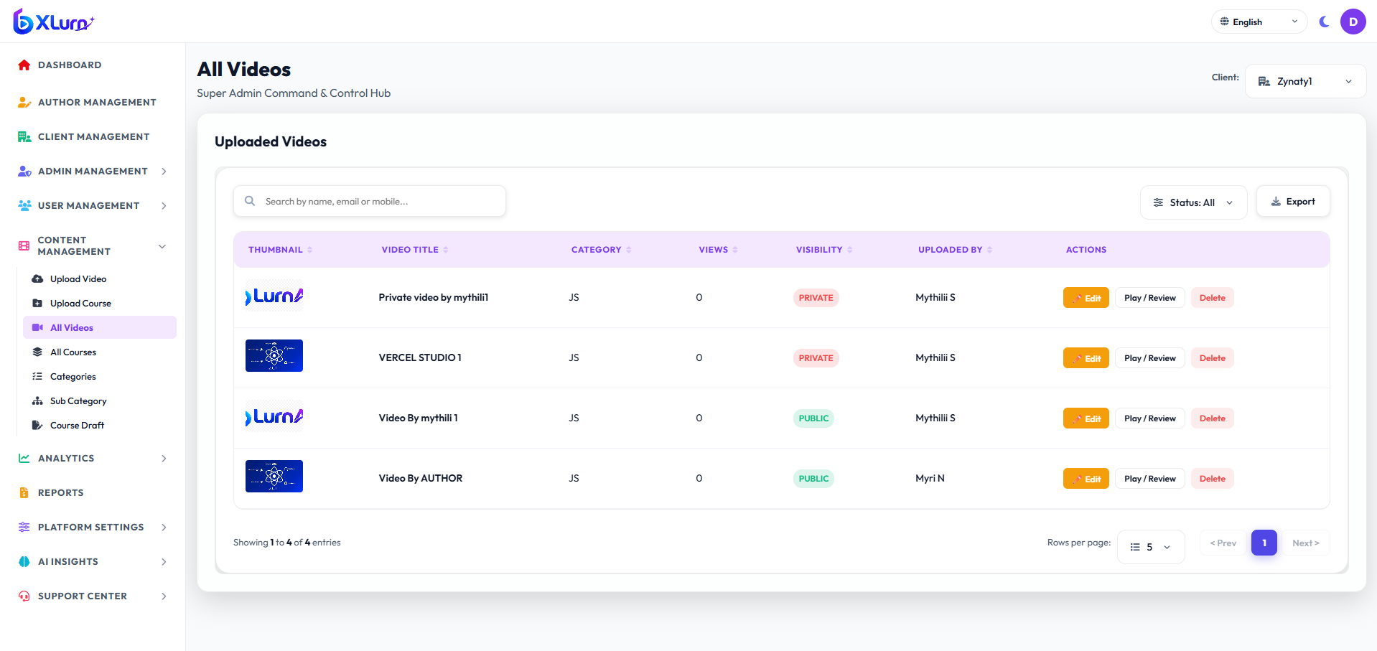

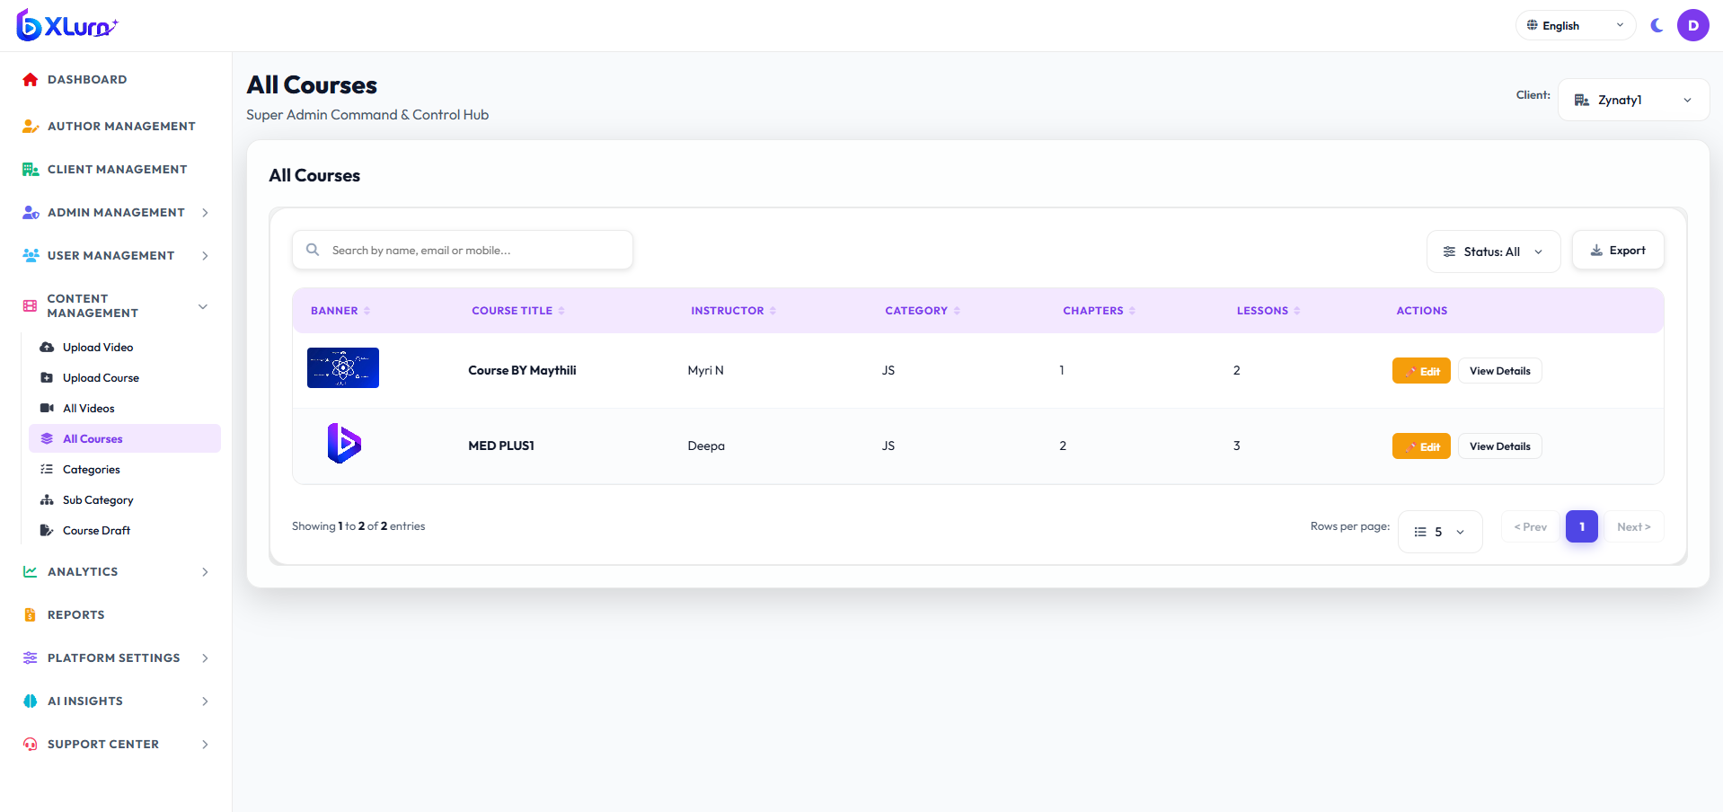

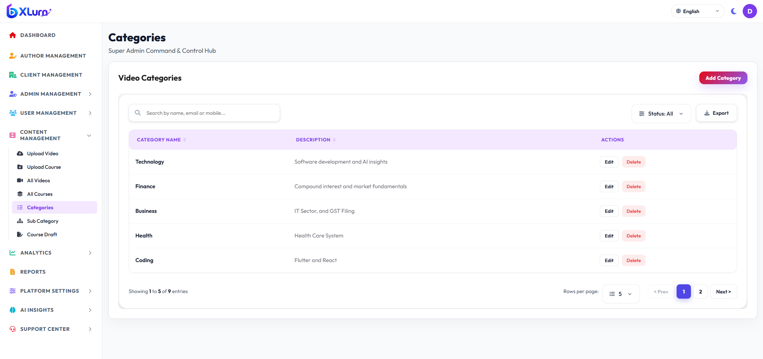

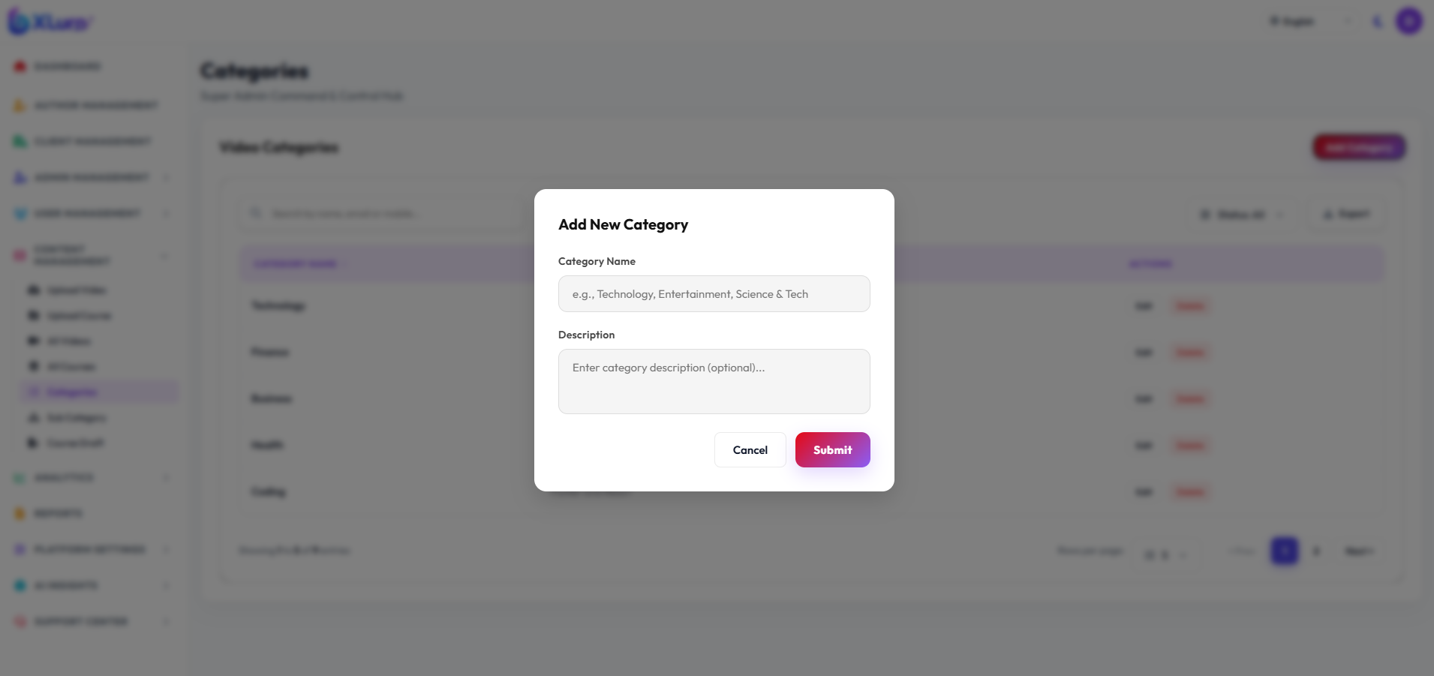

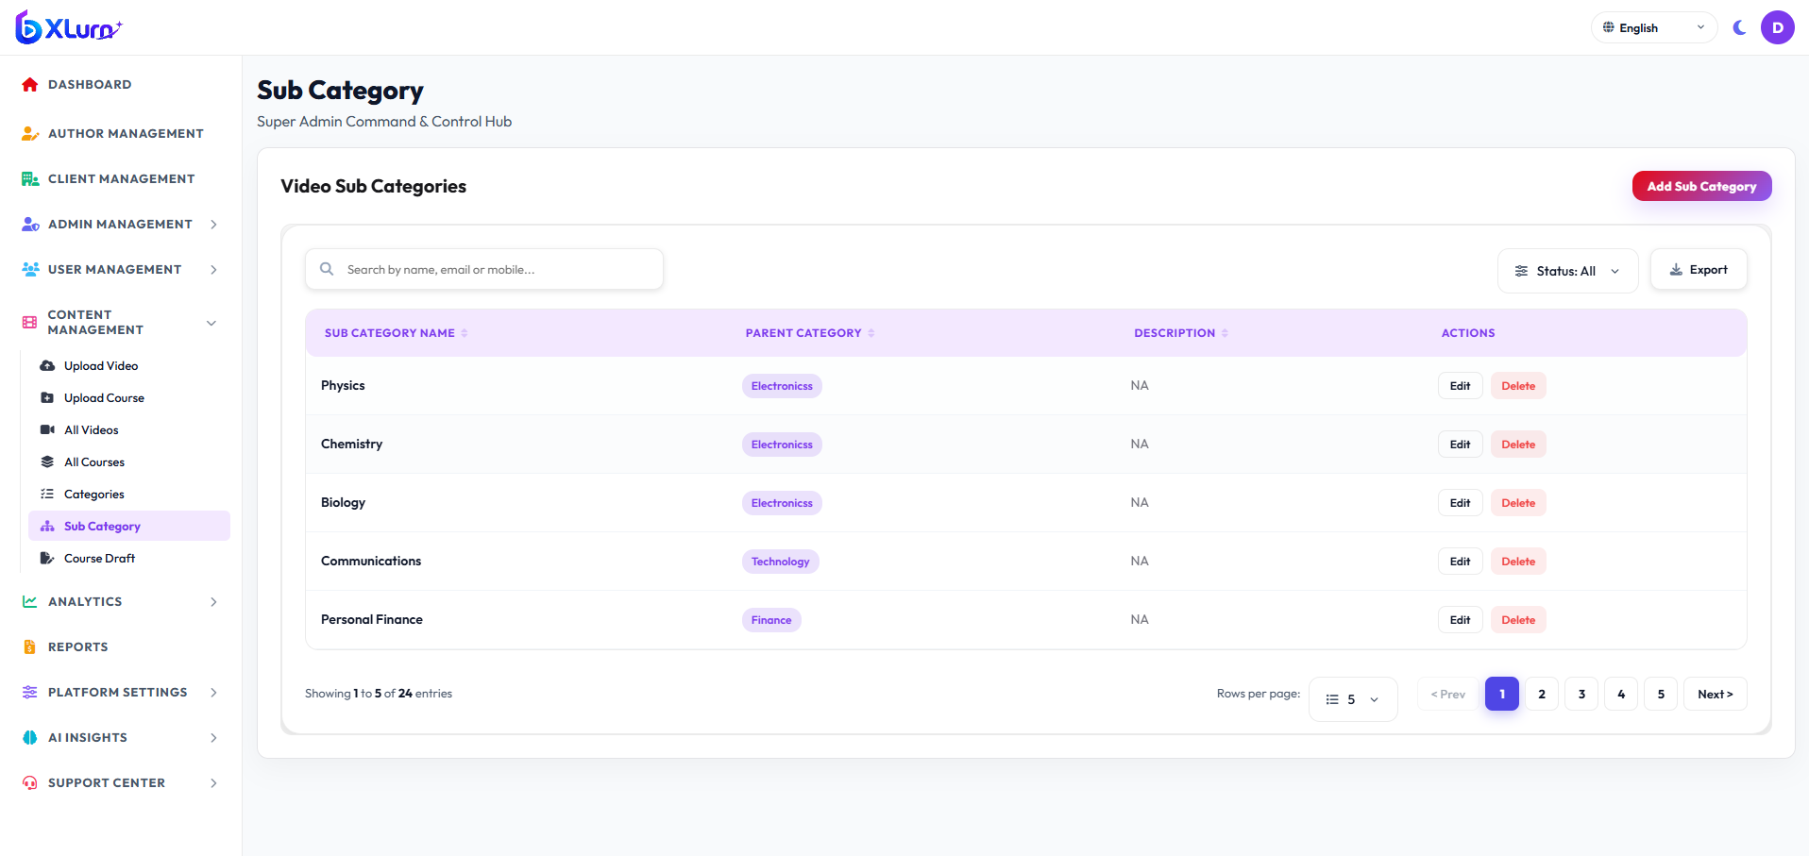

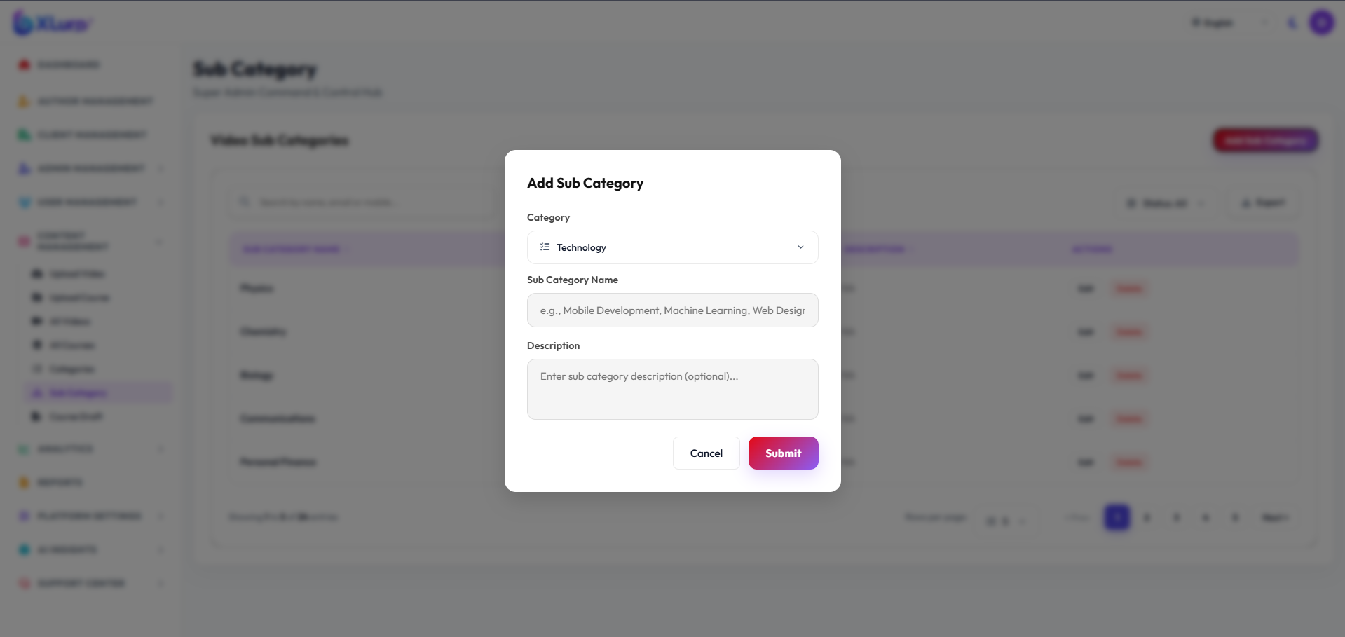

2.6 Platform Analytics, Reports, AI Insights & Support Center
Objective: Leverage predictive AI models and manage support tickets.
Features & Procedures:
1. AI Insights:
• User Analytics : Understand how users watch videos, including views, watch time, completion, and engagement, to improve content and user experience.
• Reports: Get clear insights and summaries of video performance, user engagement, and overall platform activity for better decision-making.
2. Support Center:
• Review incoming support tickets, bug reports, and user complaints.
• Update ticket status (Open, In Progress, Resolved, Closed).
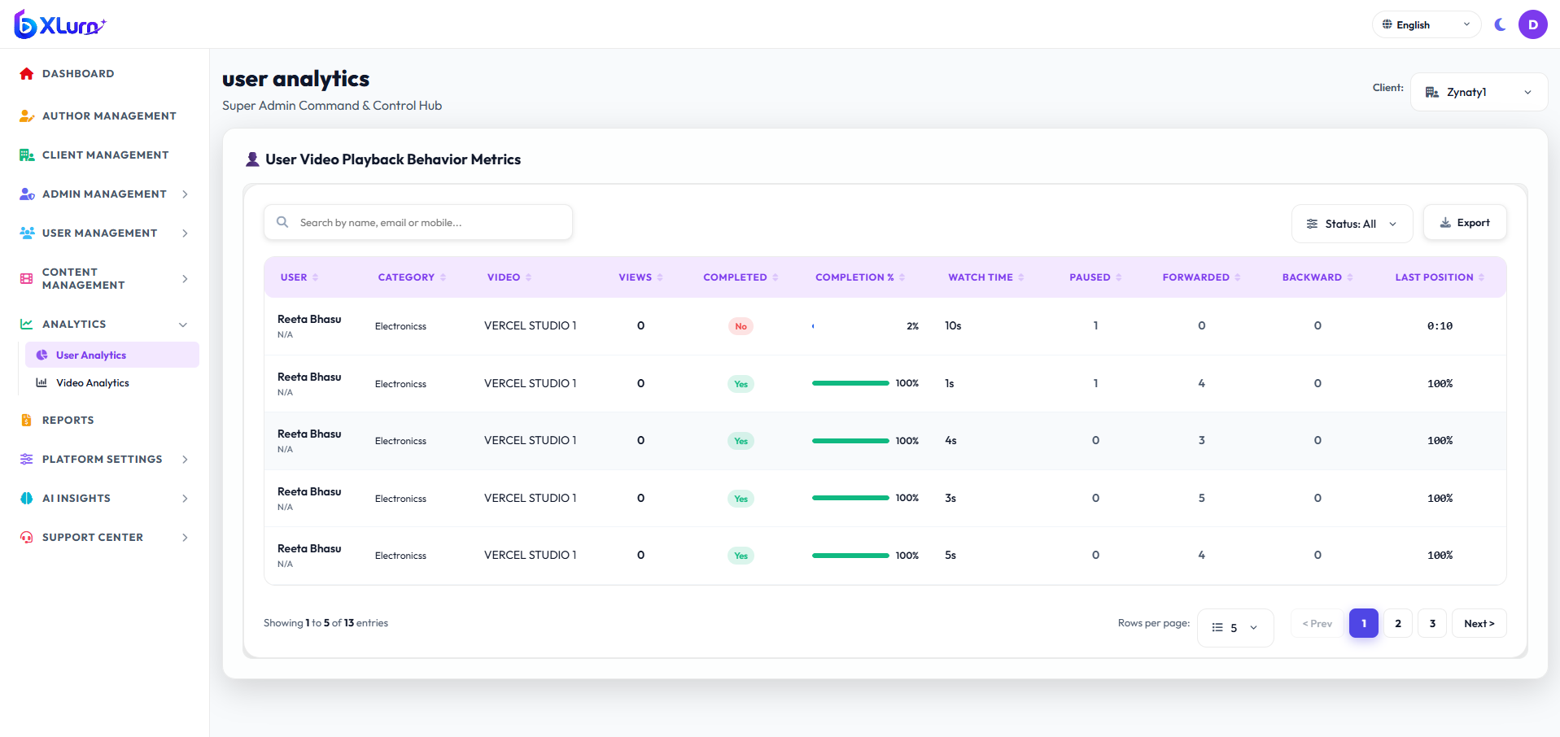

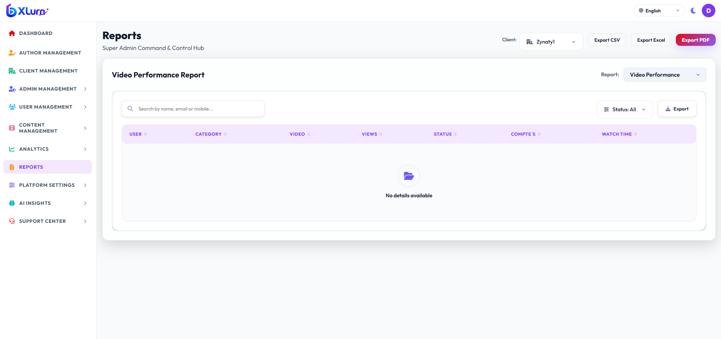

3. Section B: Client Admin (Organization Admin) SOP Manual

3.1 Admin Authentication & Dashboard Overview
Objective: Organization-level governance, local video catalog performance, and team monitoring.
Step-by-Step Navigation:
1. Access the Admin Web Portal.
2. Input Client Admin credentials and submit login.
3. Access Dashboard:
• Top KPI Cards: Total Courses, Total Authors, Total Active Learners, Watch Hours Completed.
• Recent Uploads Table: Status of latest transcoded videos.
• Interactive Charts: Daily user active trends and category popularity breakdown.
4. Header Utilities:
• Language Switcher: Click the globe icon dropdown in the top navigation bar (🌐 English, हिंदी, ಕನ್ನಡ) to change portal locale on the fly.
• Theme Switcher: Toggle Dark / Light mode using the Sun/Moon icon.
• Profile & Logout: Access account details or initiate secure single/cross-tab logout.
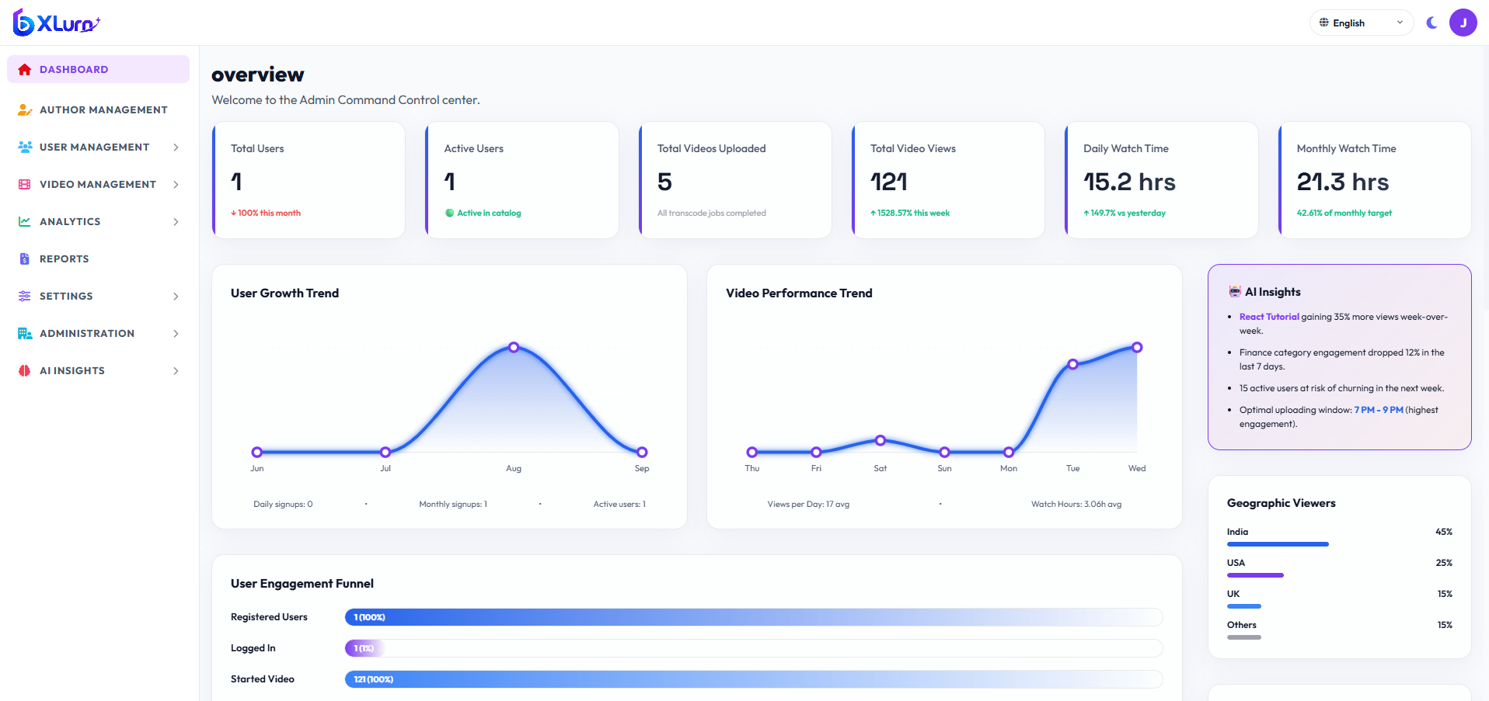

3.2 Author (Instructor) Management
Objective: Registering and managing content instructors within the organization.
Step-by-Step Navigation:
1. Click Author Management on the sidebar.
2. Add New Author:
• Click `+ Add Author` button.
• Fill in:
• Author Name: First and Last name.
• Email Address: Corporate email for login credentials.
• Designation / Title: e.g., Senior Technical Lead, Math Faculty.
• Biography: Brief profile displayed to learners.
• Avatar / Profile Photo: Upload author portrait image.
• Click Save Author.
3. Actions: Edit author details, assign courses, or disable author access.
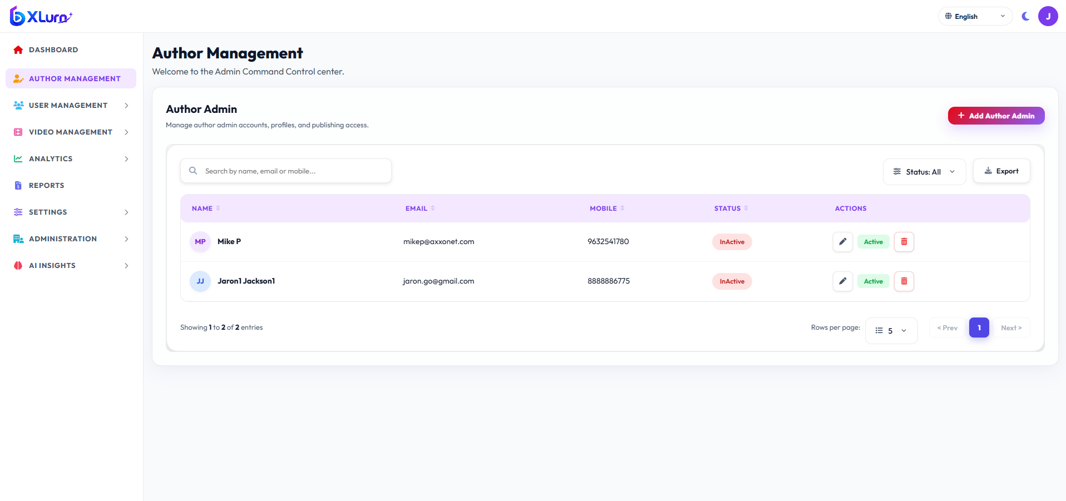

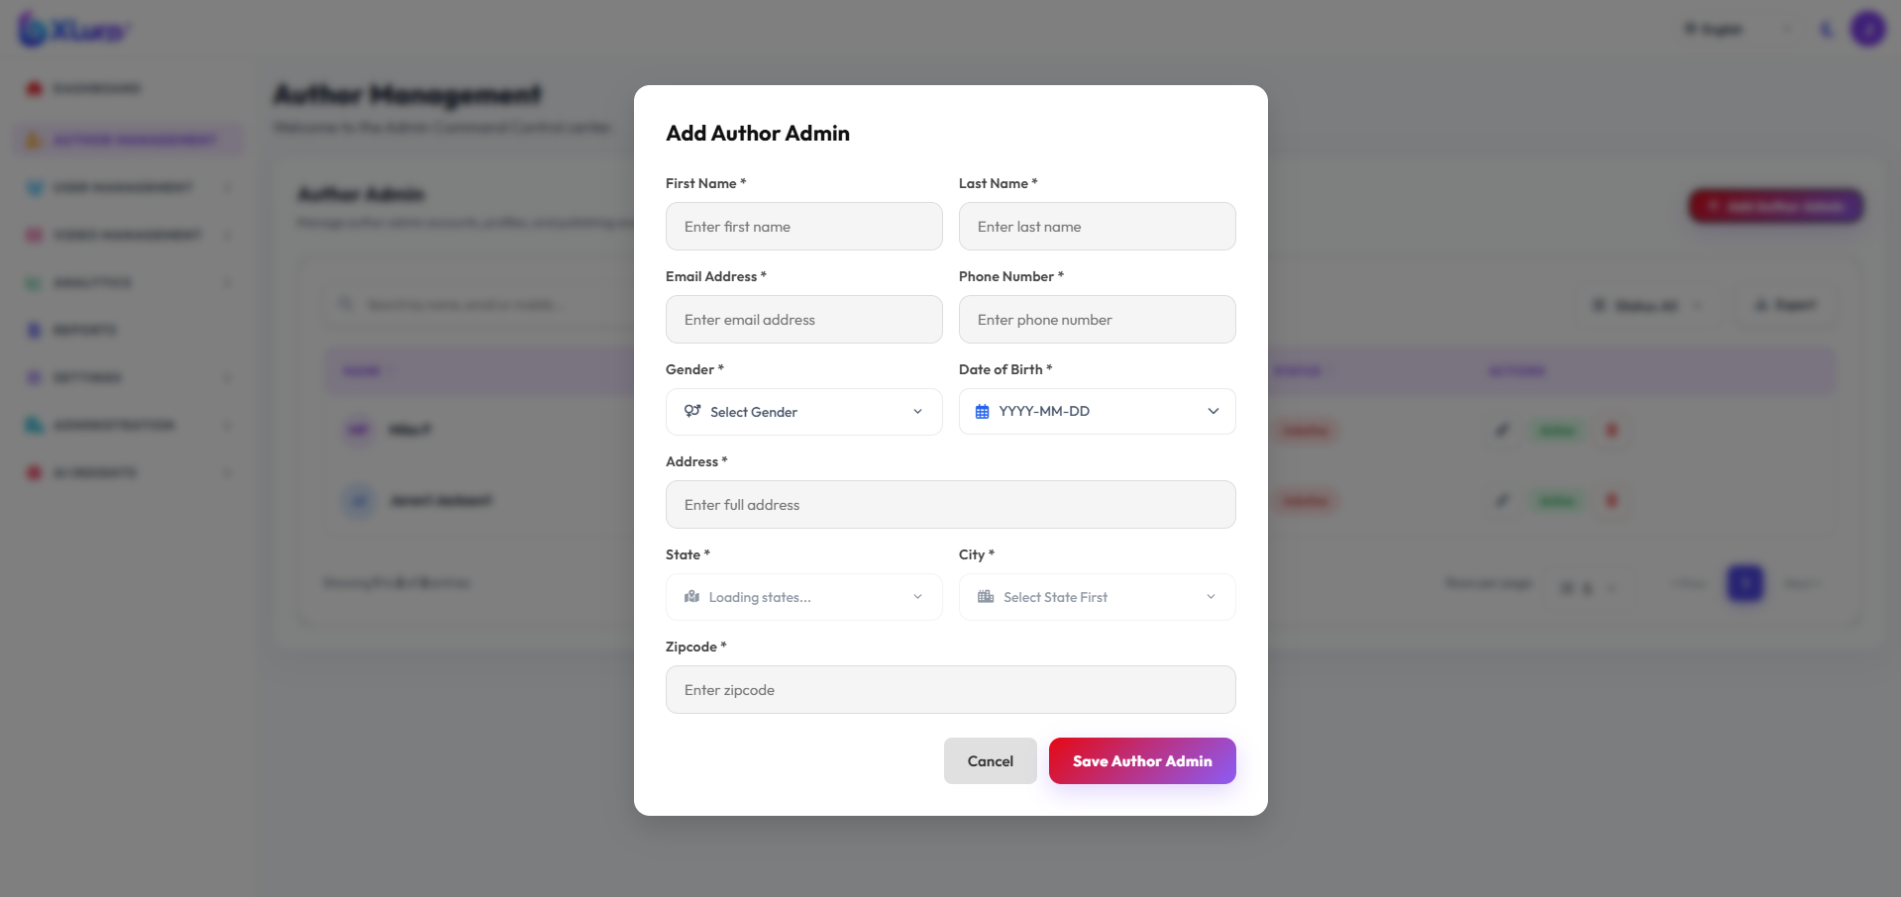

3.3 Student / User Management & Activity Logs
Objective: Managing enrolled learners, reviewing activity timelines, and enforcing access rules.
Step-by-Step Navigation:
1. Click User Management:
• Users: Search by name/email, inspect enrolled courses, view assigned plan (Free vs Premium).
• User Activity Logs: Filter logs by student ID to view video playback sessions, quiz score submissions, and timestamps.
• Blocked Users: Block problematic accounts or unblock accounts upon review.
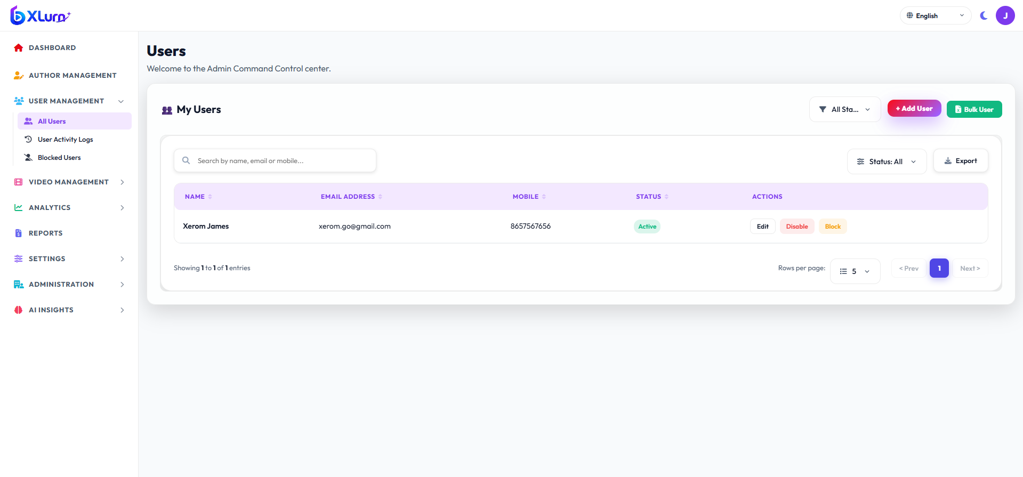

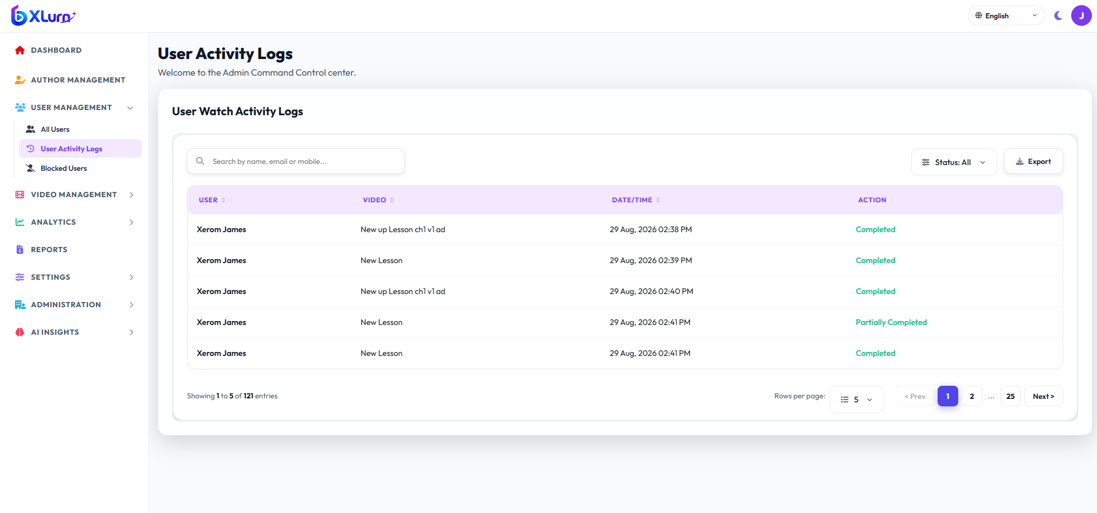

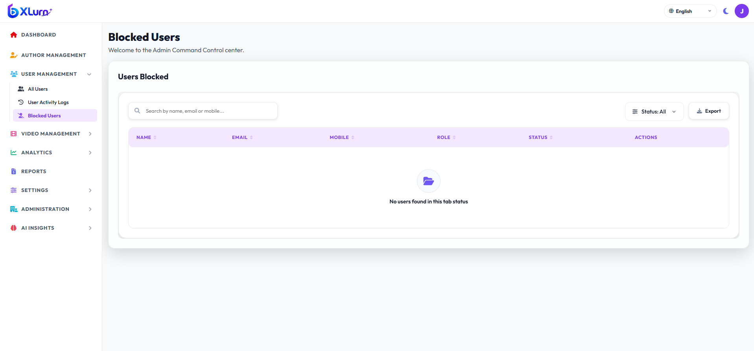

3.4 Content & Video Catalog Management
Objective: Central repository of standalone video media and published courses.
Step-by-Step Navigation:
1. Click Video Management -> All Videos:
• Displays video thumbnail, title, category, views counter, visibility badge (Public / Private), and transcoding status.
2. Edit Video Metadata:
• Click the pencil icon next to any video.
• Edit Title, Description, Tags, Category, Subcategory, and Visibility:
• Public (Free): Accessible to Free plan tier learners.
• Private (Premium): Locked for Free plan users; accessible exclusively to paid subscriber tiers.
• Click Save Changes.
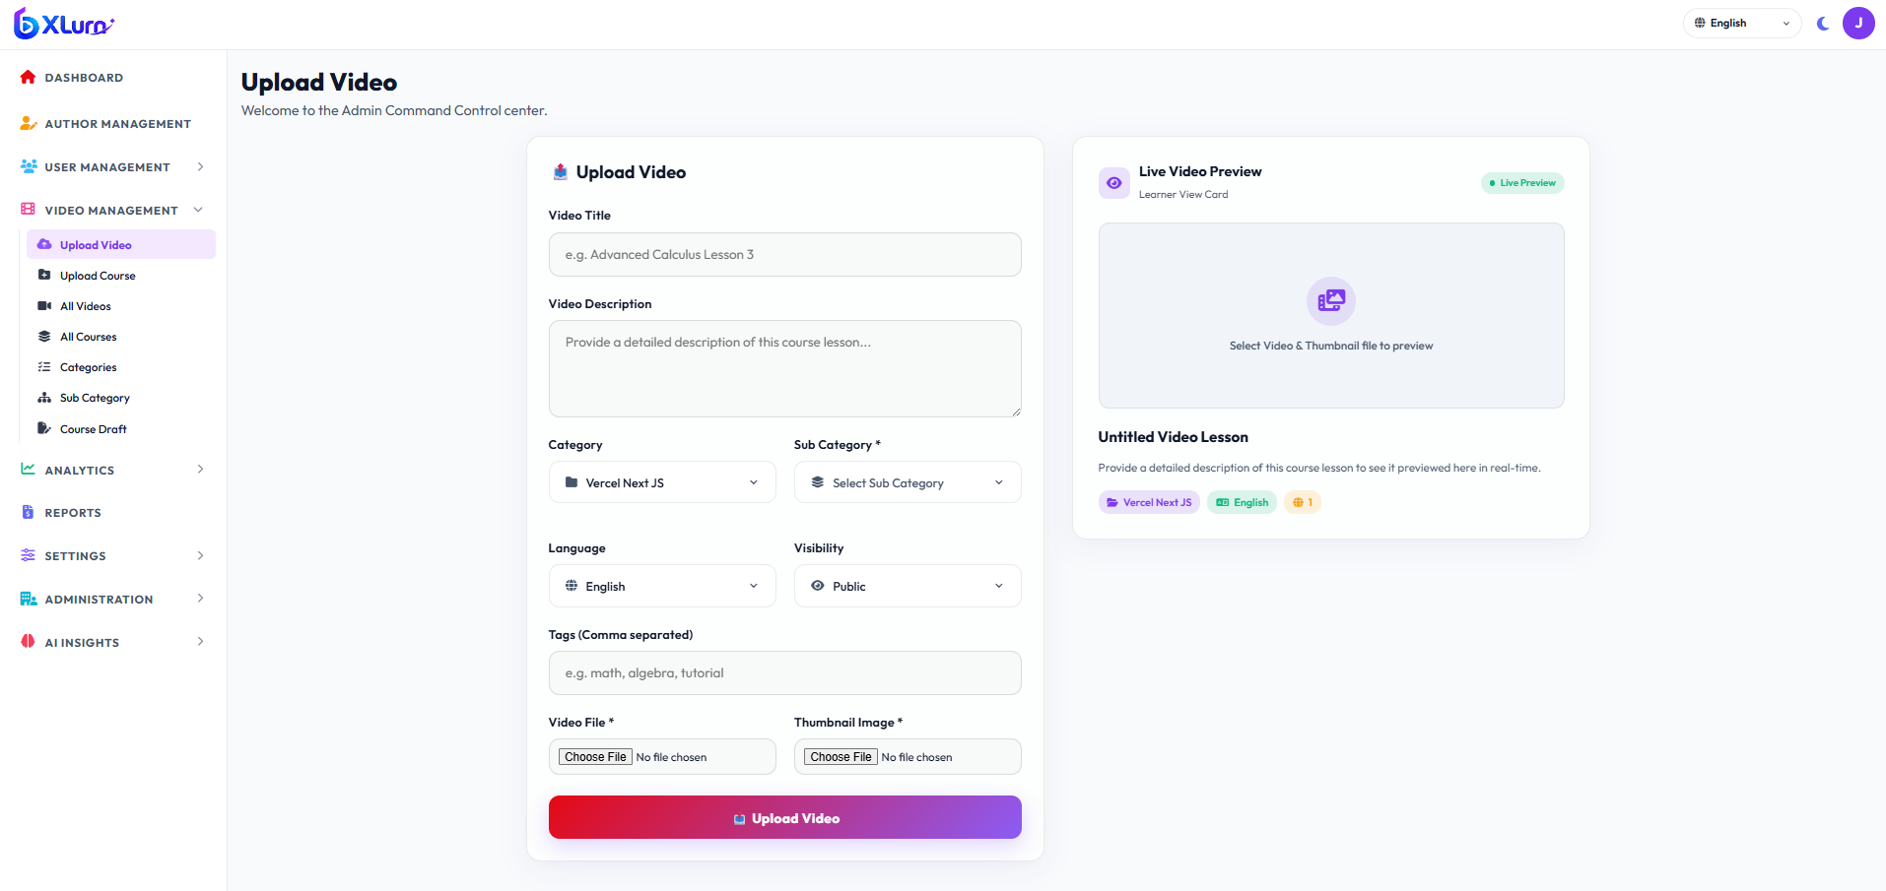

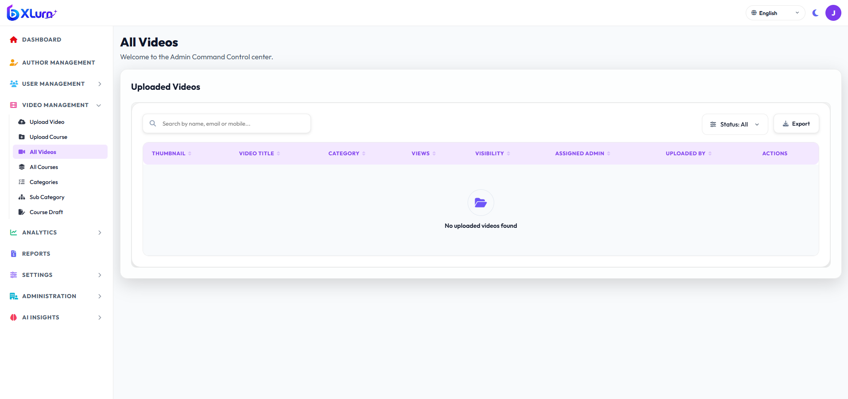

3.5 Course Upload & Curriculum Builder
Objective: Constructing multi-chapter, multi-lesson courses with integrated assessments.
Step 1: Course Basic Metadata
1. Navigate to Video Management -> Upload Course.
2. Provide core course information:
• Course Title: Descriptive title of the course.
• Category & Sub Category: Select from dropdown.
• Language: Select audio/content language (e.g., English, Hindi, Kannada).
• Level: Beginner / Intermediate / Advanced.
• Course Thumbnail: Upload 16:9 ratio promotional cover image.
• Visibility: Set Public (Free) or Private (Premium).
• Course Description: Overview, objectives, and prerequisites.
Step 2: Curriculum Builder (Chapters & Lessons)
1. In the Curriculum section, click `+ Add Chapter`.
2. Enter Chapter Title (e.g., Chapter 1 : Introduction to Microservices).
3. Under the chapter, click `+ Add Lesson`:
• Lesson Title: Specific topic title.
• Select Video: Pick from uploaded video media or upload a new video file.
• Lesson Visibility: Toggle whether this specific video is Free or Locked (Private).
• Duration: Automatically computed from video duration.
4. Repeat to add additional lessons and chapters.
5. Drag and reorder chapters and lessons as needed.
Step 3: Publish or Save Draft
• Click Save as Draft to review later in the Course Draft tab.
• Click Publish Course to immediately make it live for learners.
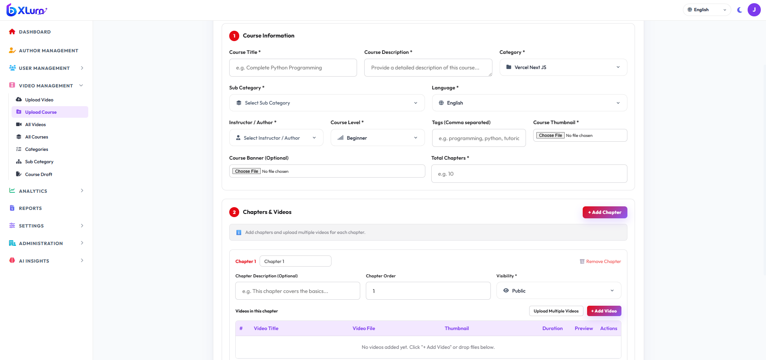

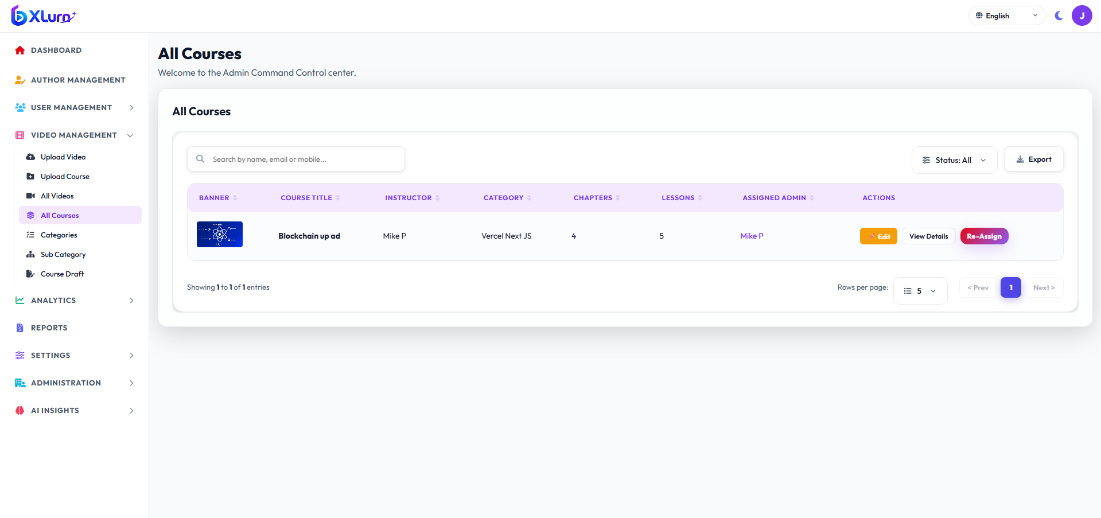

3.6 Quiz & Assessment Engine Management
Objective: Creating chapter assessments to evaluate learner retention before advancing.
Step-by-Step Navigation:
1. In Course Edit or Curriculum Builder, locate the target Chapter.
2. Click `+ Add / Manage Chapter Quiz`.
3. Configure Quiz Properties:
• Quiz Title: e.g., Chapter 1 Knowledge Assessment.
• Passing Score: Percentage required (e.g., 70%).
4. Add Questions:
• Click `+ Add Question`.
• Choose Question Type:
• Multiple Choice (MCQ): Input Question Text, add Option A, B, C, D, and select the radio button for the correct answer.
• True / False: Input statement and select True or False as the answer.
• Fill in the Blanks / Free Text: Input question prompt and define the accepted reference answer string.
5. Click Save Quiz.
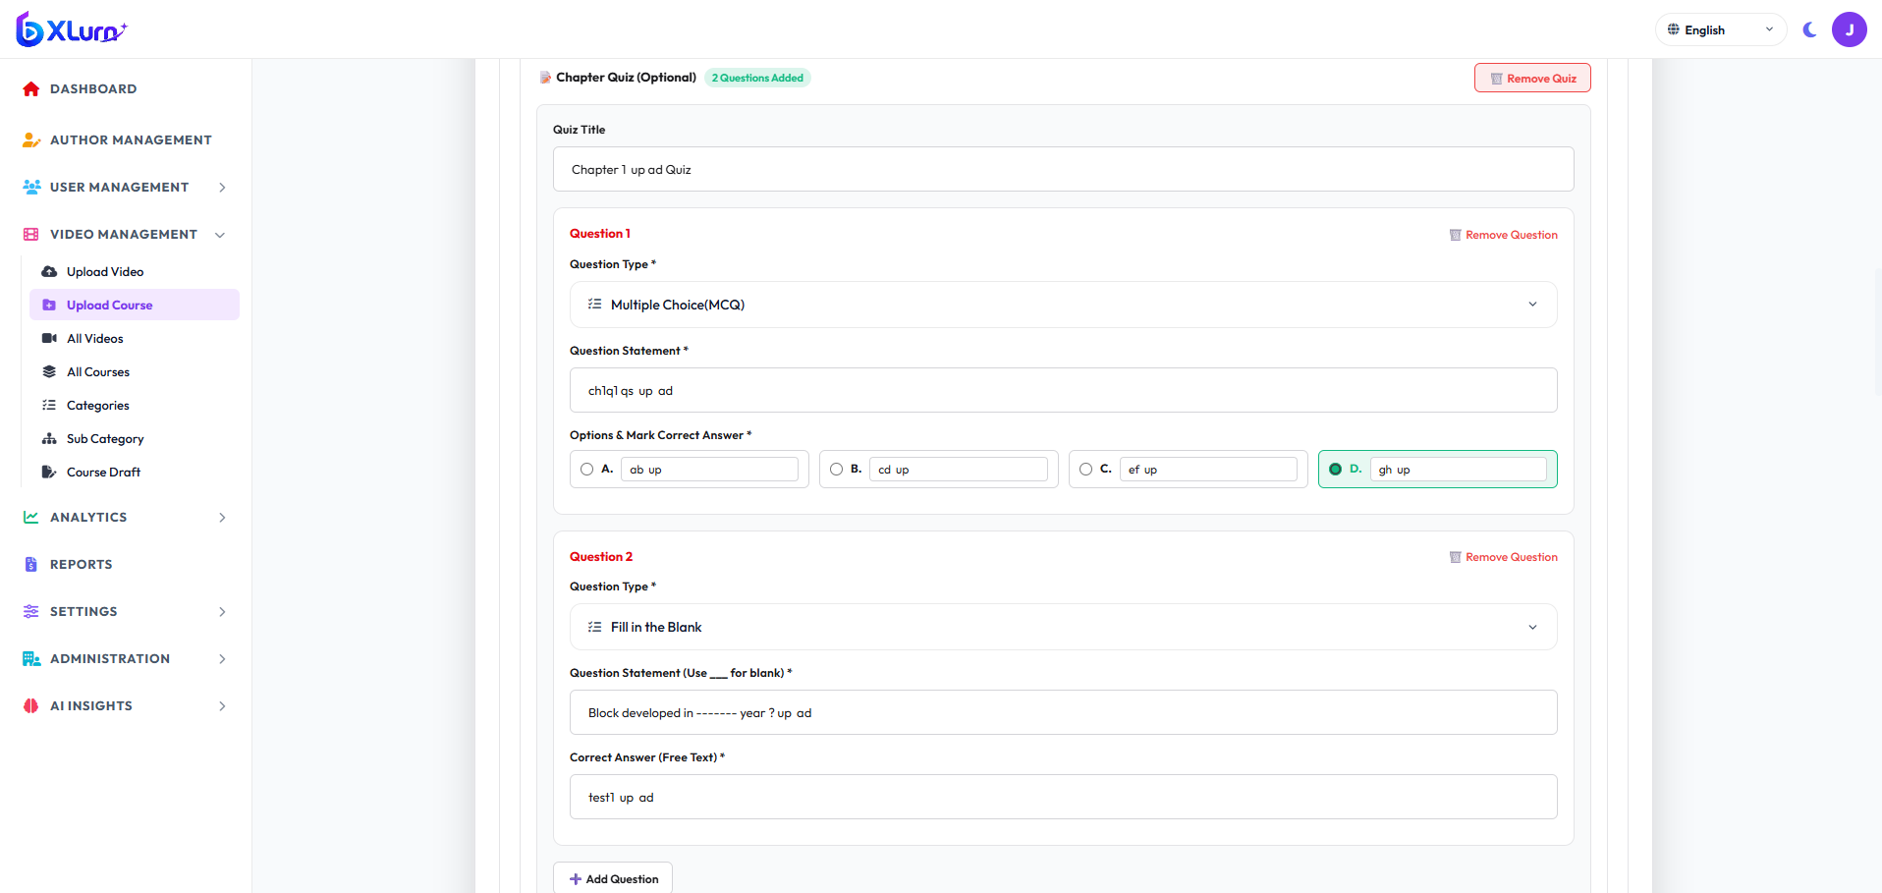

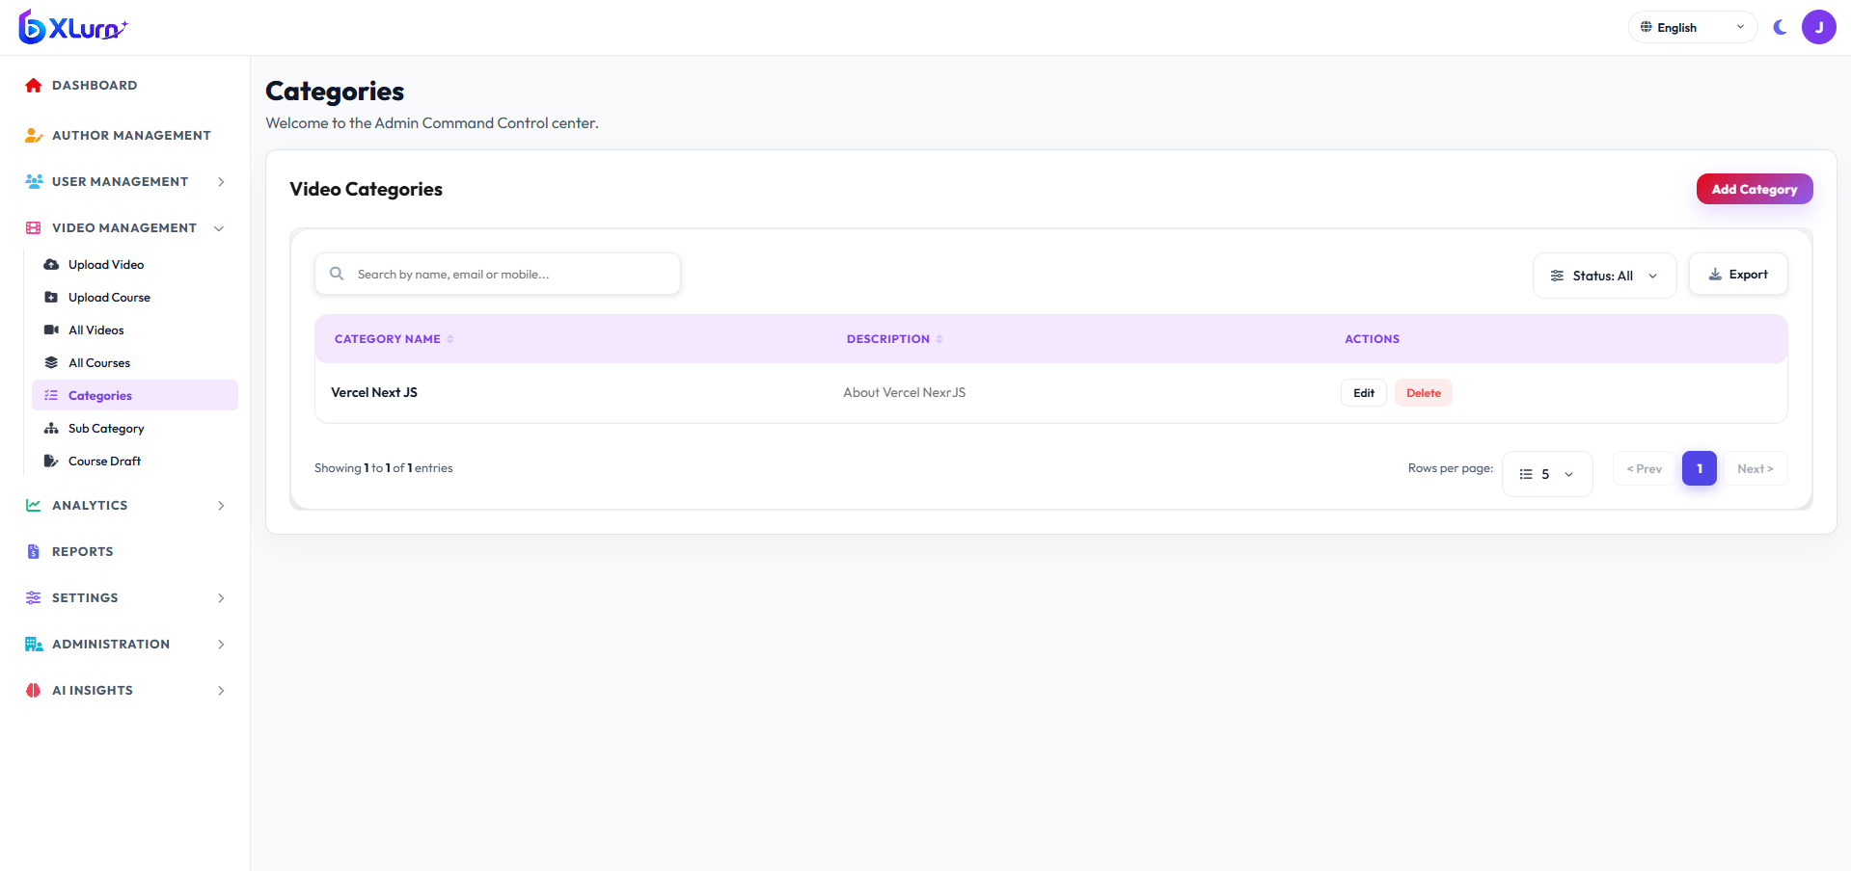

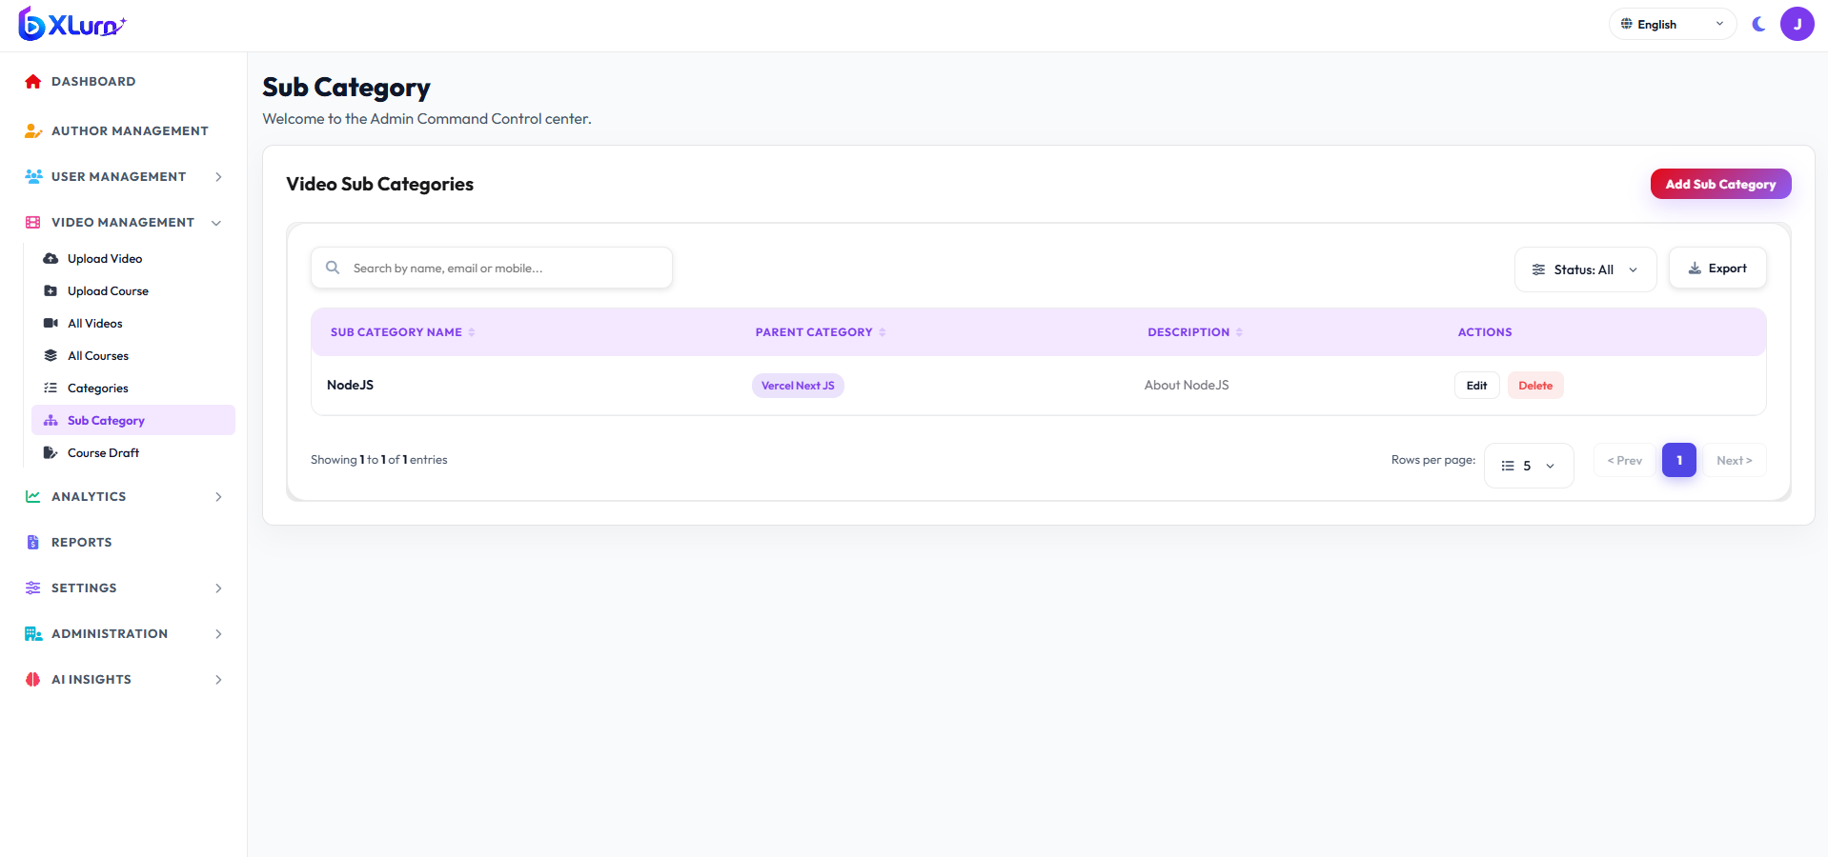

3.7 User Activity And Reports
Objective: Granular role-based delegation and non-repudiation audit logging.
Step-by-Step Navigation:
1. Navigate to Analytics And Reports:
• Understand how users watch videos, including views, watch time, completion, and engagement, to improve content and user experience.
• Reports: Get clear insights and summaries of video performance, user engagement, and overall platform activity for better decision-making.
• Audit Logs: Immutable log tracking every administrative mutation (Course Deleted, User Suspended, Role Modified) with actor timestamp and IP address.

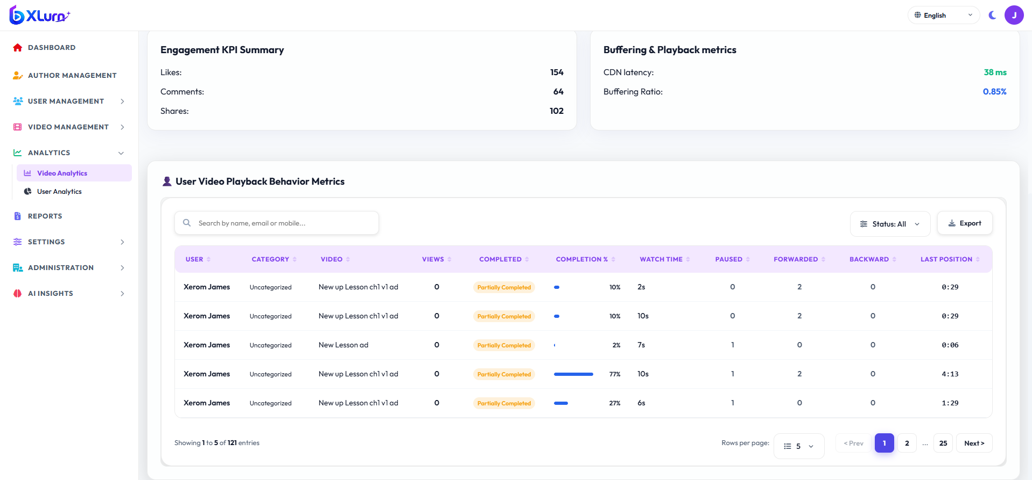

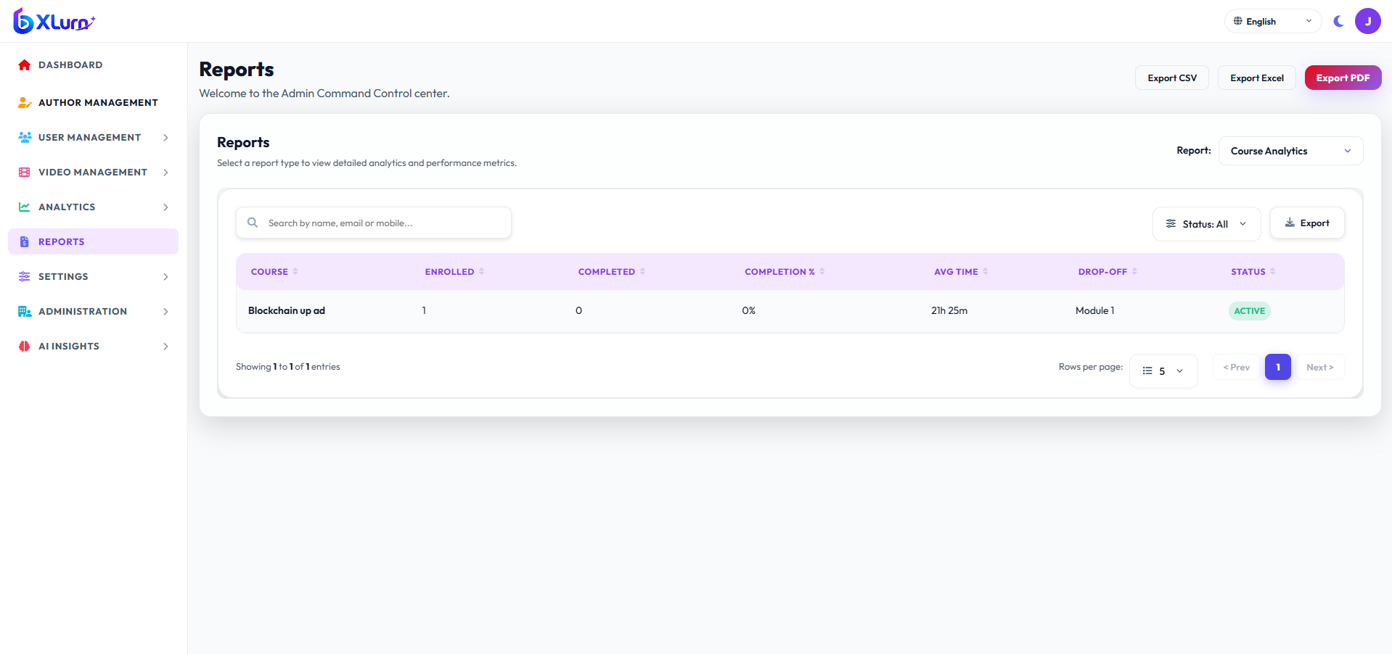

4. Section C: Author Admin (Instructor / Content Creator) SOP Manual

4.1 Author Dashboard & Studio Workspace
Objective: A focused workspace for instructors to create, update, and monitor their own courses and content.
Step-by-Step Navigation:
1. Log in using Author Admin credentials.
2. The Author Dashboard displays:
• My Active Courses & Drafts
• Total Students Enrolled in My Courses
• Student Course Completion Rate
• Quiz Pass / Fail Ratios
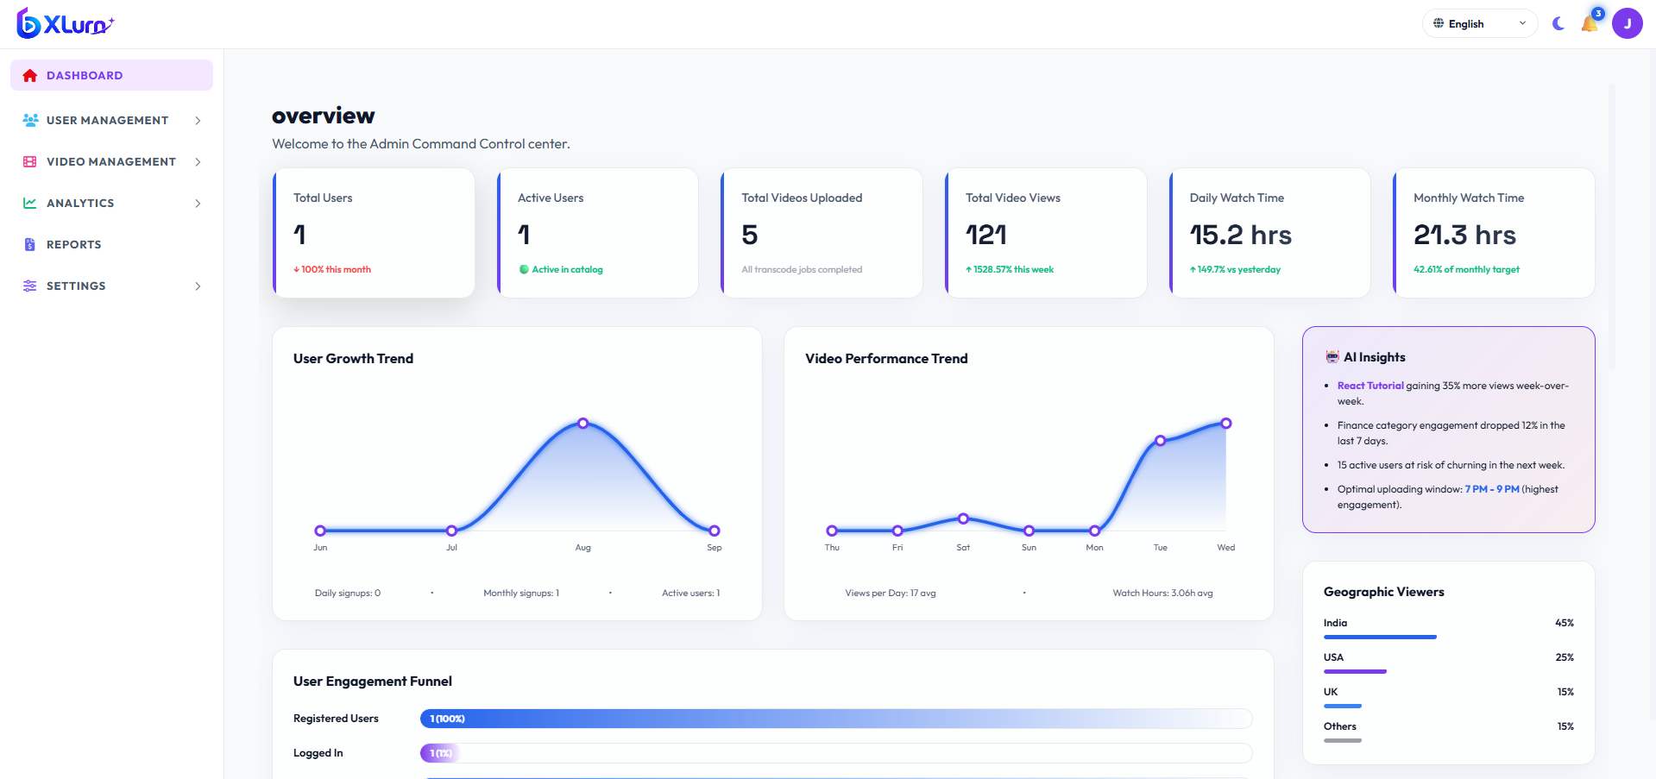

4.2 Video Upload & Transcoding Pipeline
Objective: Uploading high-definition video master files for automated multi-resolution transcoding.
Step-by-Step Navigation:
1. Click Upload Video on the sidebar.
2. File Selection:
• Drag and drop your .mp4, .mov, or .mkv video file into the upload dropzone.
3. Metadata Entry:
• Video Title: Clear, descriptive lecture name.
• Category: Select subject category.
• Description: Detailed lecture notes, code snippets, or links.
• Custom Thumbnail: Upload high-contrast thumbnail image.
4. Upload Execution:
• The upload service breaks large files into chunks with progress bar indicators.
• Once uploaded, the background transcoding service encodes versions for:
• 1080p (FHD)
• 720p (HD)
• 480p (SD)
• Auto (Adaptive Bitrate)
5. When status changes to Ready, the video can be linked to any course chapter.
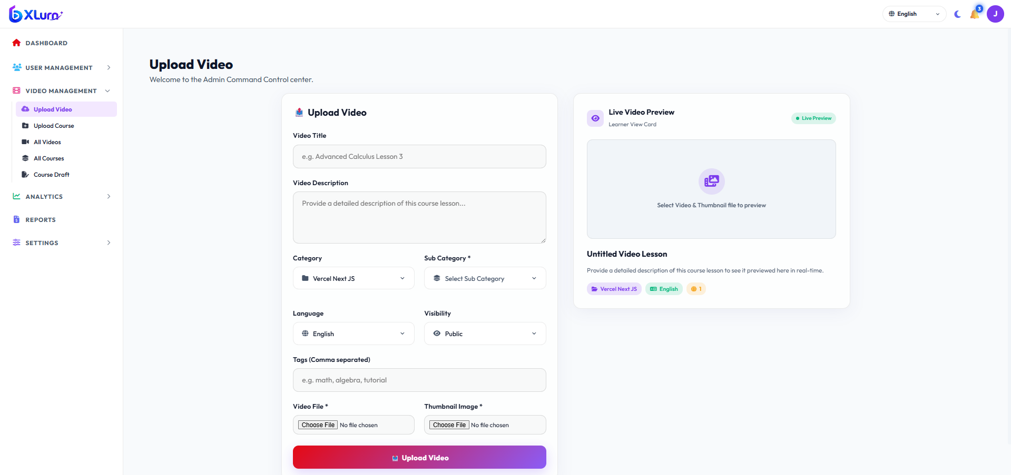

4.3 Course Curriculum Authoring & Draft Workflow
Objective: Structuring authored courses into logical chapters.
Authoring Rules:
• Courses must have at least 1 Chapter with at least 1 Lesson Video.
• Chapters should be numbered sequentially (Chapter 1 : [Title], Chapter 2 : [Title]).
• Use Save Draft frequently during curriculum drafting.
• Once complete, submit the course for Client Admin approval or publish directly (based on assigned author permissions).
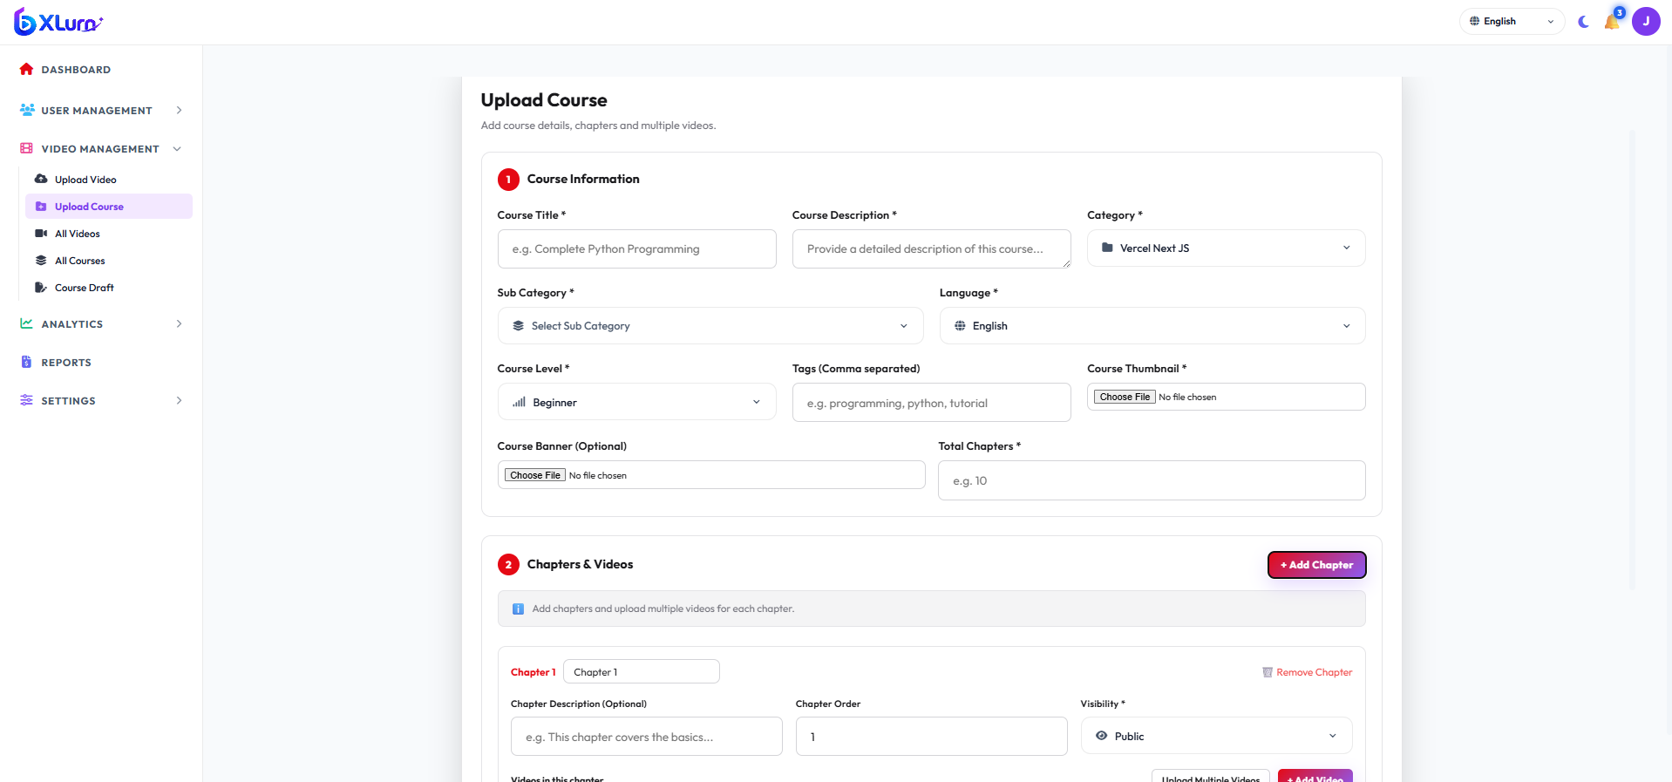

4.4 Interactive Quiz Question Creation
Objective: Authoring end-of-chapter quizzes to test student comprehension.
Question Authoring Guidelines:
• MCQ: Provide 3 to 4 distinct options with exactly one correct answer.
• True / False: Ensure statements are unequivocal.
• Free Text / Fill in the Blanks:
• The student assessment interface enforces non-empty inputs.
• Formulate questions with concise, clear answer expectations.
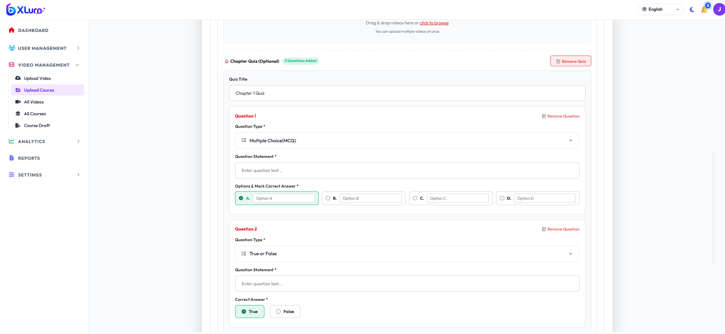

5. Section D: End Learner (User) Portal SOP Manual

5.1 Account Registration, Login, OTP & Password Recovery
Objective: Secure access to courses, personalized watch progress, and saved lists.
Registration Flow Of Self SignUp:
1. Open User Web App (http://localhost:3001).
2. Click Sign Up.
3. Fill in: Full Name, Email Address, and Password.
4. Submit the registration form.
Login Flow:
1. Click Sign In.
2. Enter registered Email and Password. Click Login.
3. Single-Session & Inactivity Protection: Inactive tabs are monitored with automatic session synchronization. If deactivated by an administrator, the platform triggers an alert notifying the learner.
Password Recovery Flow:
1. On the Sign In page, click Forgot Password?.
2. Enter registered email address to receive an OTP / reset verification.
3. Alternatively, update password inside Profile -> Change Password.
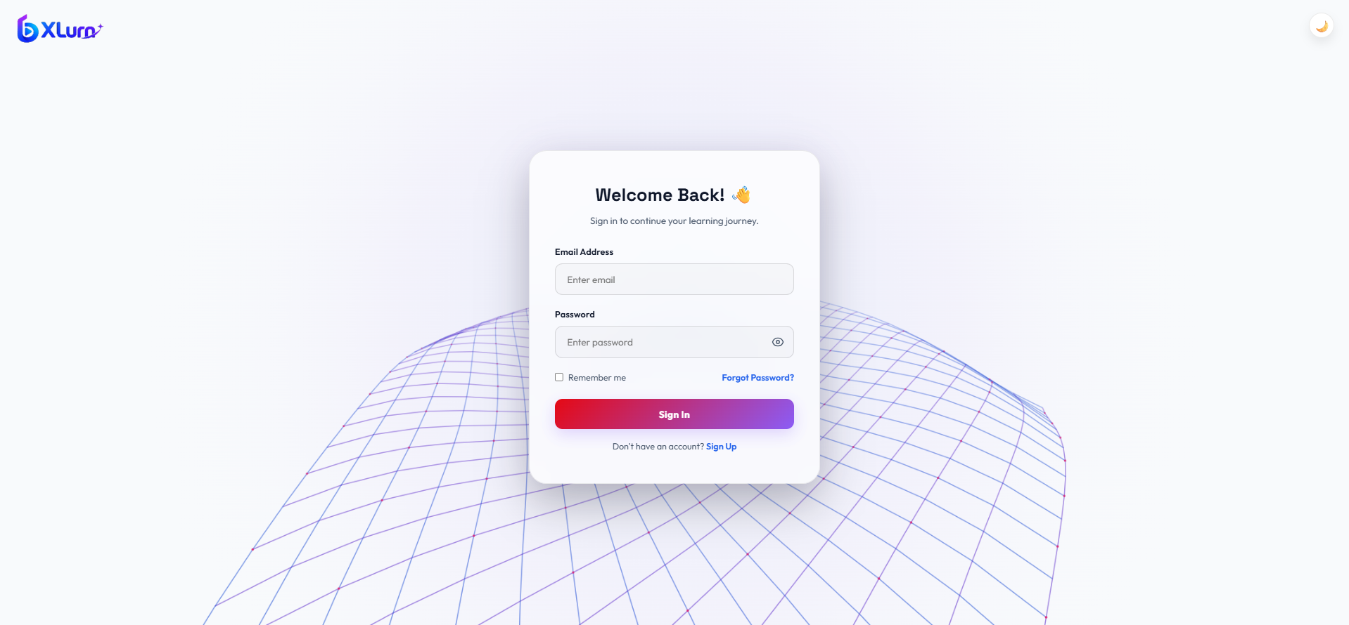

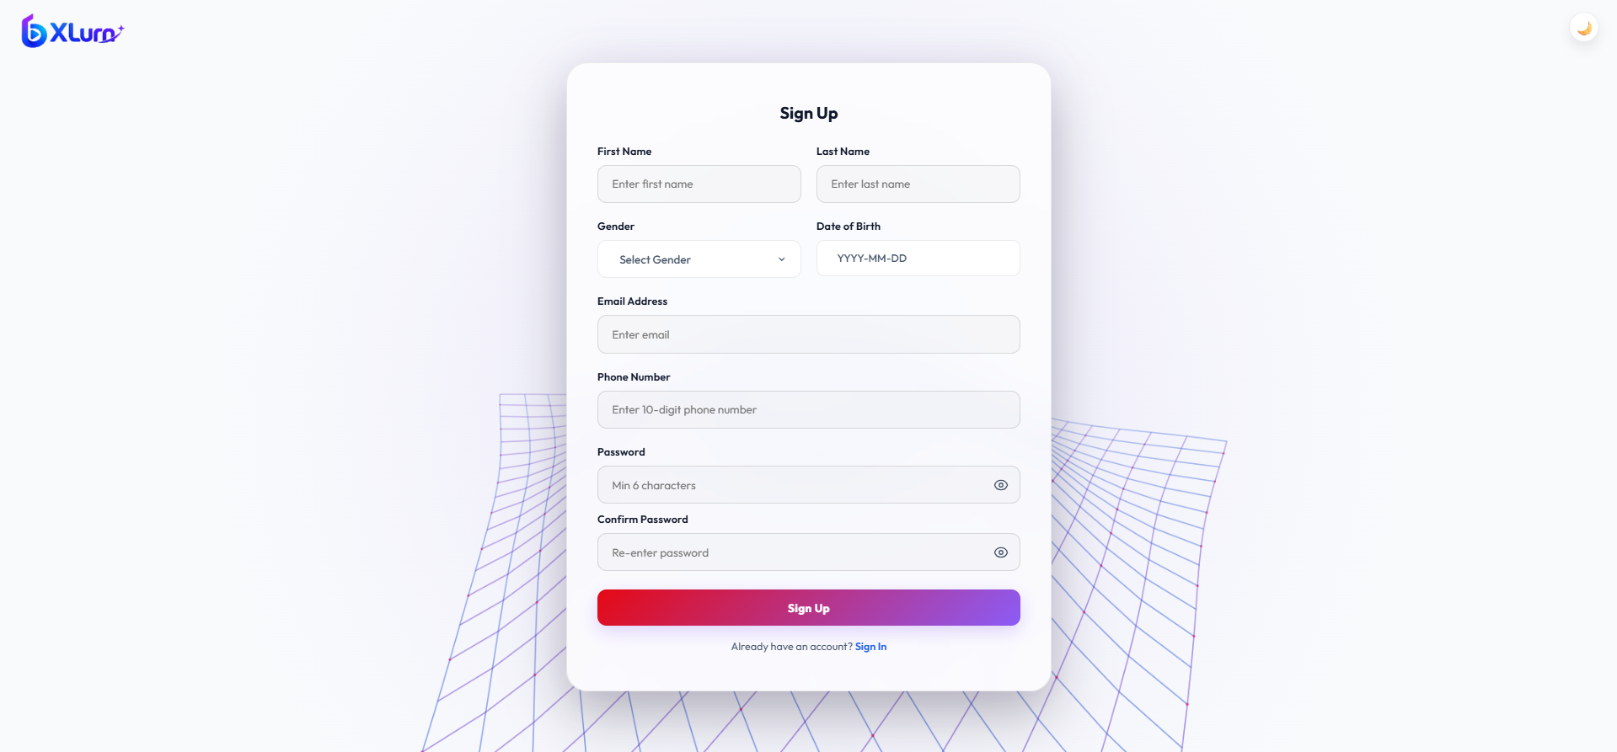

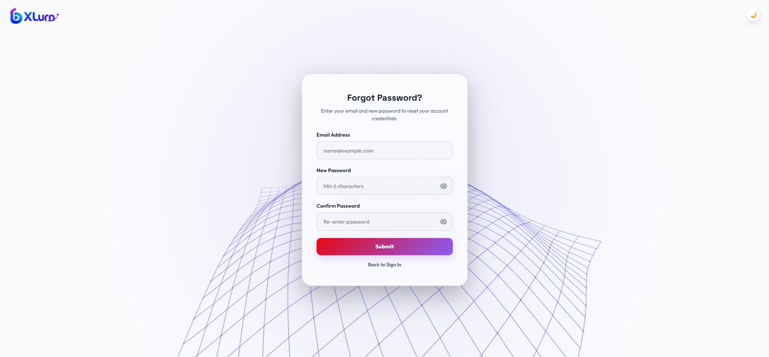

5.2 Home Feed, Category Browsing & Search
Objective: Discovering courses, filtering by subject, and continuing recent lessons.
Navigation Features:
1. Hero Banner: Highlights featured and newly released courses.
2. Recently Played Bar: Displays your latest in-progress video with progress bar and a 1-click Resume button.
3. Category Chips: Filter the catalog by Development, Design, Cloud & DevOps, AI & Machine Learning, etc.
4. Universal Search: Type keywords into the top navigation search bar to retrieve instant course and lecture suggestions.
5. Language Switcher: Click the top-right globe (🌐 English, हिंदी, ಕನ್ನಡ) to change the UI language dynamically.
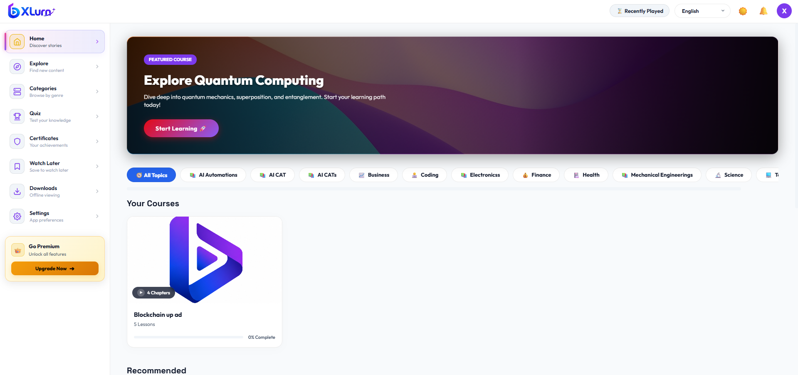

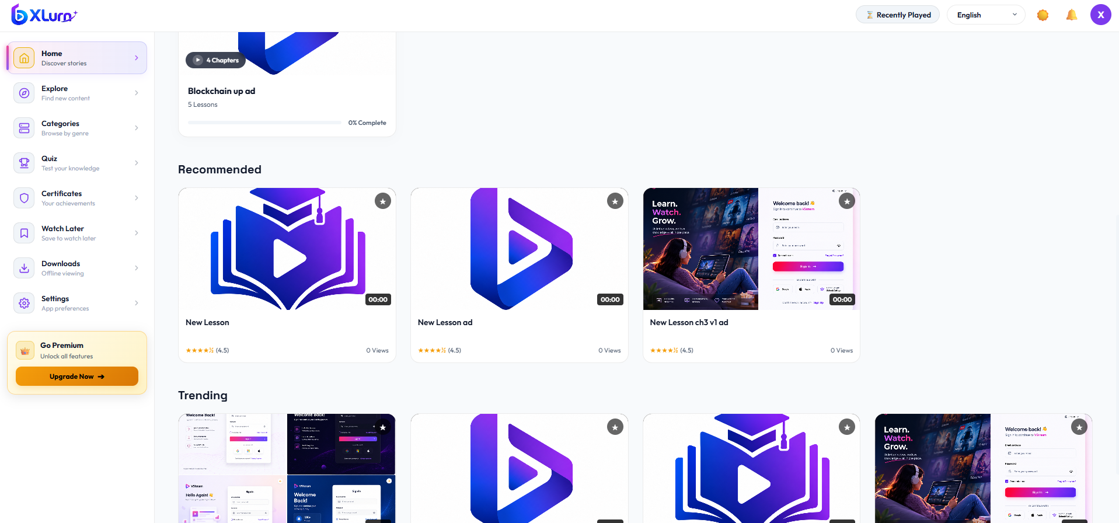

5.3 Course Enrollment & Video Watch Room
Objective: Navigating the unified Course Watch interface with synchronized sidebar curriculum.
Step-by-Step Navigation:
1. Click any course card from the catalog.
2. You enter the Video Watch Room:
• Left Column: Main interactive video player, lecture metadata, description, and action buttons.
• Right Column: Course Content accordion organized cleanly by Chapter 1 : [Title], Chapter 2 : [Title], etc.
3. Locked Lesson Handling (Free vs Premium Plans):
• Lessons marked with a lock icon are Premium-only content.
• For Free Plan users, if a chapter contains only 1 video and that video is private, the thumbnail is blurred with a centered lock badge.
• If a chapter has multiple videos with a mix of public and private lessons, accessible videos remain playable.
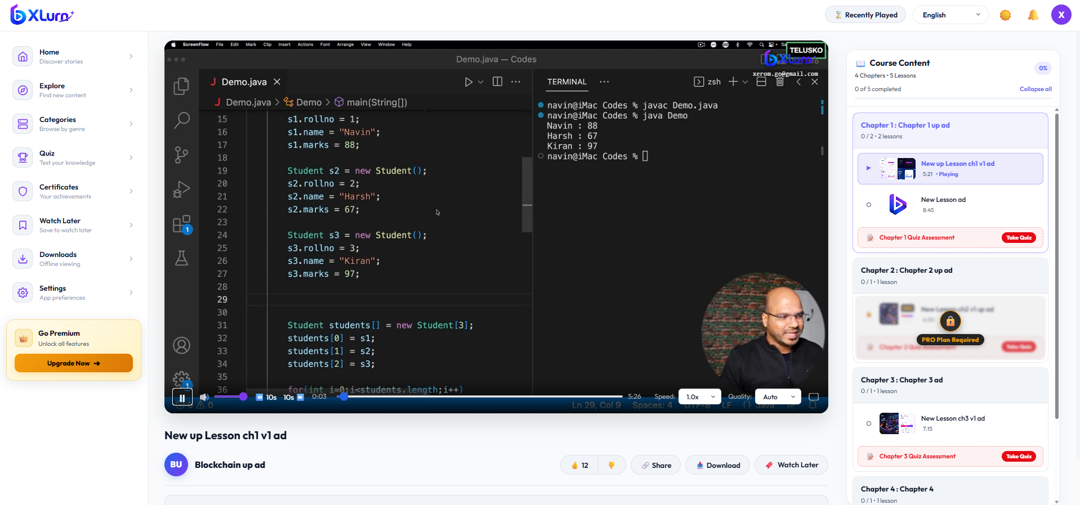

5.4 Video Player Controls, Anti-Piracy Watermarks & Fullscreen
Objective: High-fidelity video playback with custom security protection.
Video Player Feature Guide:
1. Playback Controls:
• Play / Pause: Spacebar shortcut or center click on video.
• 10s Jump: Quick skip backward (-10s) or forward (+10s).
• Speed Selector: Choose from 0.75x, 1.0x (Normal), 1.25x, 1.5x, 2.0x.
• Quality Selector: Switch between Auto, 1080p, 720p, and 480p with buffering indicator overlay.
• Auto-Resume Prompt: Remembers playback timestamp across devices; displays a prompt to Resume or Start Over.
2. Anti-Piracy Dynamic Watermarks:
• Top-Right Brand Logo: High-definition platform logo directly on video with drop shadow.
• Dynamic User Email: Monospace anti-piracy watermark displaying your logged-in email directly under the logo.
3. Fullscreen Mode:
• Click the expand icon to enter native fullscreen. The player container maintains custom controls and watermark overlays in full resolution.

5.5 Chapter Quizzes & Assessment Submissions
Objective: Verifying chapter mastery and unlocking subsequent course modules.
Workflow & Automation:
1. Automatic End-of-Chapter Trigger:
• When all playable videos in a chapter are watched, the Chapter Quiz Assessment automatically launches in a focused modal.
• Alternatively, click the red Take Quiz button under the completed chapter in the sidebar.
2. Answering Questions:
• Multiple Choice: Click the circular radio option.
• True / False: Select True or False card.
• Free Text / Fill in the Blanks:
• Type your answer in the text box.
• Validation Rule: The input strictly prevents leading and empty whitespace. The Next ➔ and Submit Quiz 🚀 buttons remain disabled until valid text is entered.
3. Results & Auto-Advance:
• Immediate score card calculation upon submission.
• Click Continue Course:
• The system automatically navigates to the next unlocked video.
• Smart Auto-Advance: If the immediate next chapter's first video is private/locked, the engine automatically skips it to launch the second playable video, or advances to the next playable chapter.
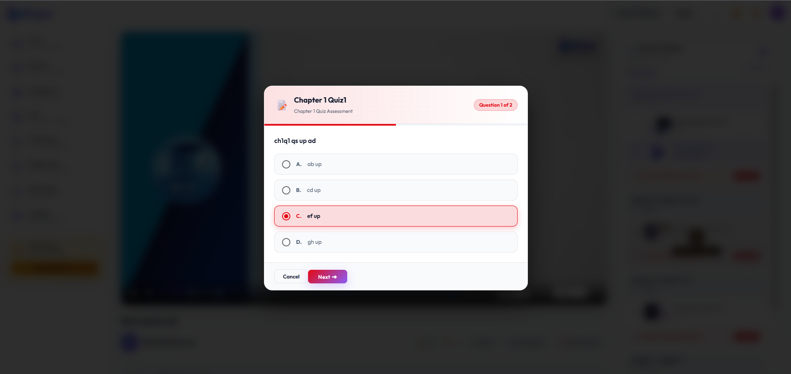

5.6 Watch Later & Favorites Workflow
Objective: Bookmarking lectures for subsequent study.
Step-by-Step Navigation:
1. Under the video title, click the `🔖 Watch Later` pill button.
2. System Response & Custom Alert:
• First Time Added: A custom success alert displays with a green checkmark icon:
• > "Video has been added to watch later."
• Already Exists (HTTP 431 / Duplicate): A custom informational alert displays with an indigo bookmark icon:
• > "Video is already in watch later."
• The button maintains its clean, standard look for seamless continuous browsing.
3. Accessing Saved Videos:
• Navigate to Sidebar -> Watch Later to view your collection.
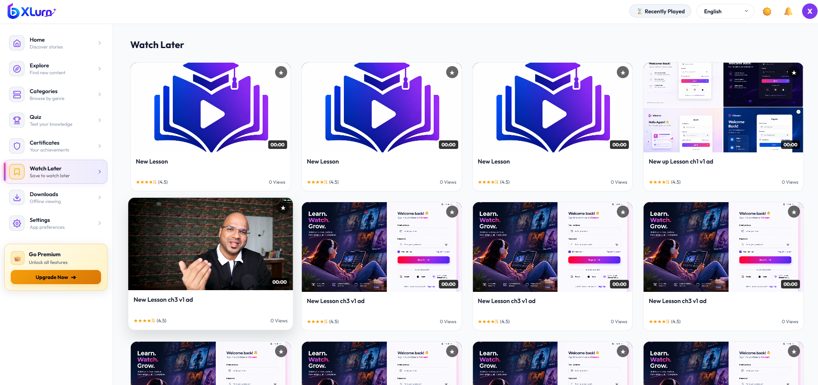

5.7 Profile Settings, Security & Subscription Plans Upgrade
Objective: Profile customization, password updates, and tier upgrades.
Step-by-Step Navigation:
1. Click your user avatar in the top right -> select Profile.
2. Profile Tab: Update full name, avatar, view total watch hours and quizzes completed.
3. Security Tab: Update your password with real-time validation.
4. Subscription Upgrade Flow:
• Navigate to Plans & Pricing (/plans).
• Toggle billing frequency (Monthly / Yearly - 20% Discount).
• Review Tier Comparison:
• Free Tier (Current): Standard resolution, access to public community courses.
• Pro Tier: HD streaming, access to all locked private lessons, offline downloads.
• Enterprise Tier: 4K UHD streaming, 1-on-1 instructor mentoring, certificates.
• Click Upgrade Plan to proceed through the checkout flow.
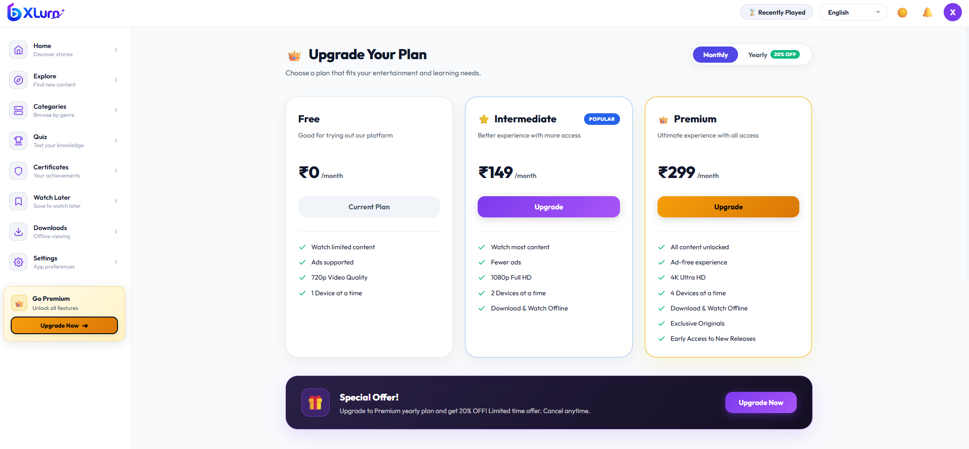

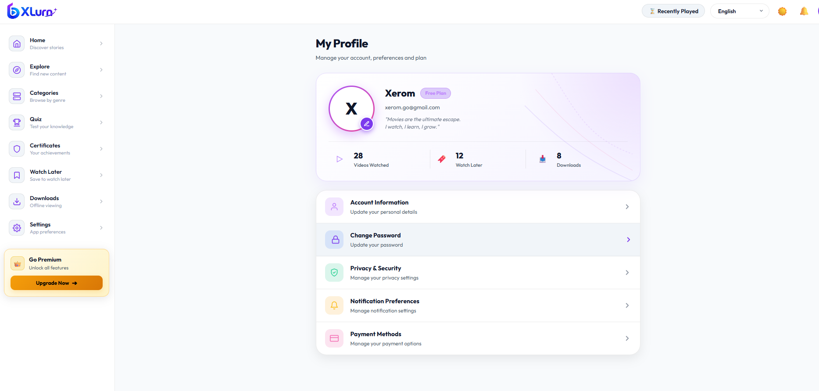

5.8 Virtual Classroom & Live Interactive Lectures
Objective: Participate in scheduled and real-time live lectures, workshops, and webinars directly from the learner portal.
Features & Interactive Tools:
1. Live Classes Directory (/live-classes): Filter sessions by All, Live Now, Upcoming, or Recorded.
2. Live Webcast Canvas (/live/:id): High-definition, low-latency live instructor video stream.
3. Real-Time Attendee Counter: Displays total active students and instructors in the session.
4. Raise Hand Feature: Allows learners to signal the instructor when questions arise.
5. Interactive Live Polls: Real-time multiple-choice voting with dynamic class percentage results.
6. Classroom Chat: Moderated group discussion with verified instructor messages.

5.9 Collaborative Study Rooms & Watch Parties
Objective: Group study sessions and peer accountability workspaces.
Features & Tools:
1. Join via 6-Character Room Code: Enter a private room code shared by a classmate.
2. Create Custom Room: Choose a course topic, set room capacity, and invite study partners.
3. Synchronized Pomodoro Focus Timer: 25-minute study intervals with 5-minute review breaks.

5.10 Community & Discussion Boards
Objective: Cross-course public student discussions, troubleshooting, and project peer reviews.
Features:
1. Topic Tags: Filter discussions by tags such as #React, #AI, #Algorithms, #SystemDesign.
2. Ask Questions: Post queries with code snippets, course references, and formatted text.
3. Upvoting Answers: Upvote verified solutions to elevate the highest-quality responses.
4. Instructor Verification Badges: Responses reviewed and endorsed by course authors.
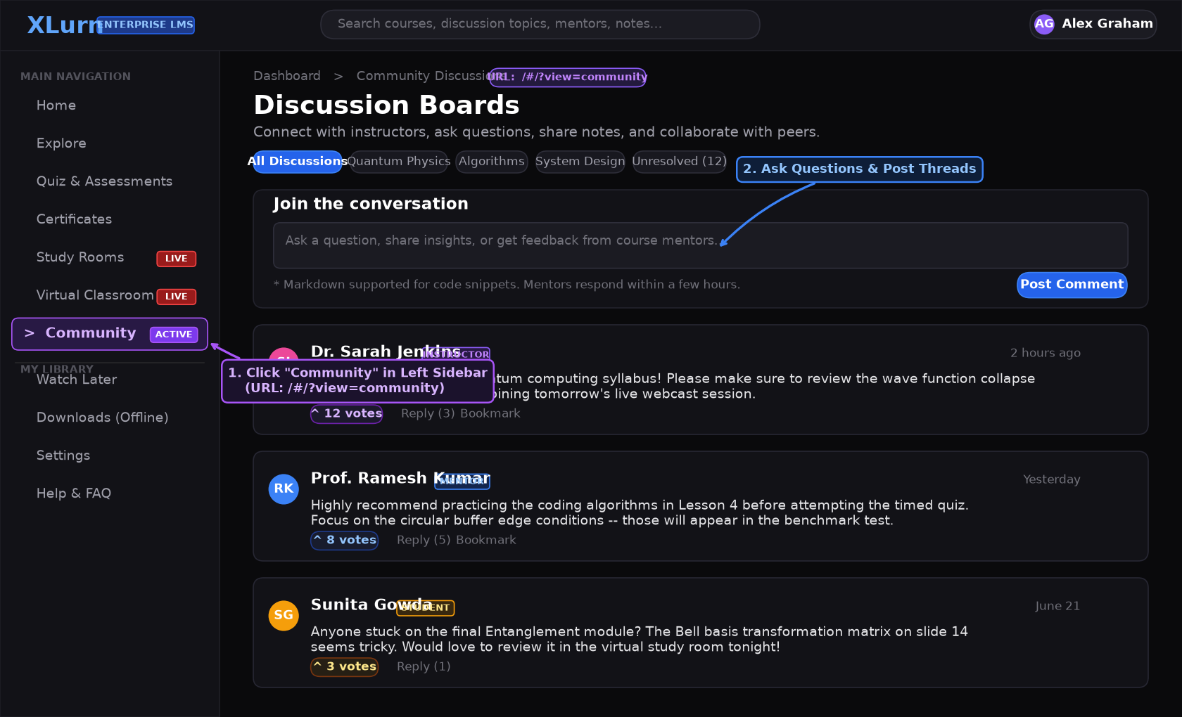
Figure 5.10: Community Discussion Boards & Topic Tag Filtering

5.11 Earned Certificates & Verified Credentials
Objective: Accessing and downloading accredited course completion credentials.
1. Open Sidebar -> Certificates (/certificates).
2. Each certificate displays Course Title, Final Grade (>= 70%), Issue Date, and Credential ID.
3. Click Download Certificate (PDF) to obtain an authenticated certificate.

5.12 Help Center & Self-Service FAQ
Objective: Instant self-service assistance for video playback, account management, and subscriptions.
1. Open Sidebar -> Help & FAQ (/faq).
2. Categorized answers for streaming resolution, quiz scoring rules, and billing.

6. Section E: System Error Codes & Troubleshooting Reference
Error Code / Trigger | User-Facing Message | System Cause | Recommended Resolution
HTTP 430 | Your account has been deactivated. Please contact your administrator for assistance. | Account suspended by Super Admin or Client Admin | Contact organization support team to reactivate access.
HTTP 431 | The video will be watched later. | Duplicate entry detected in user's saved video table | Video is already present in Watch Later list. Proceed to Watch Later to view.
Free Plan Lock | Need to upgrade your plan | Free tier learner attempting download or private lesson | Upgrade account to Pro or Enterprise plan in Plans & Pricing.
Quiz Input Disabled | Button disabled (opacity 0.5) | Free text input is blank or contains only empty spaces | Enter valid characters answering the prompt to enable the Next / Submit button.
Token Expiry (401) | Automatic silent token refresh | Access token lifespan expired | System automatically triggers /auth/refresh. If refresh token expired, user is safely redirected to Login.

Enterprise Video Streaming & LMS Platform SOP Manual | Generated and Maintained by System Engineering Team

